

MSc. in Computer Science – Team Project

Interim Report

Team 1 – Data Polish

Oluwatobi Omole D22125039

Sean McCrossan D22124413

Umama Sumlin Tasnuva D22124465

Naveen Maheswaran D22124491

Nikodem Adamski C18415776

Table of Contents

1. Introduction 7

2. User Scenario 8

2.1. Identification of Target Users 8

2.2. Reasons for Target users Studying Data Science 9

2.3. User Personas 10

2.4. Problems for target users 13

2.5. Survey feedback 13

2.6. Benefits of Our Product for Institutions and Data Science Students 17

2.7. Interviews 17

2.8. Conclusion 17

3. Technical Problem 19

3.1. Rationale Behind Need for the System 19

3.2. Core Technical Problems 20

3.2.1 Overview 20

3.2.2 Seamless and Inclusive User Experience 20

3.2.3 Backend related Problem 20

3.2.4 Deployment and Hosting related Problem 21

3.3. Other Existing Similar Systems 22

4. Technical Solution 24

4.1 System overview 24

4.2 Initial Design Documents 24

4.2.1 Overall System Flow 25

4.2.2 Use Case Diagram 25

4.2.3 Planned Site Map 26

4.3 Prototypes of Main Features 27

4.3 Breakdown of Key Functionalities 32

4.3.1 Data Import 32

4.3.2 Data Profile 32

4.3.3 Data Cleaning 33

4.3.4 File Export 34

4.4 Systems Architecture 35

4.4.1 Overall Systems Architecture 35

4.4.2 Cloud Deployment Architecture 36

4.4.3 Systems Architecture – Main Features 37

4.4.3.1 Data Upload 37

4.4.3.2 Data Profile 37

4.4.3.3 Data Cleaning 38

4.4.3.4 Data Download 39

4.5 Version Control System 40

4.5.1 Understanding GitHub Flow and Git Flow 40

4.5.2 Version Control Workflow for Our System 41

4.6 User Interface Design Strategies 42

4.6.1 Modern UI 42

4.6.2 Accessible UI 42

4.6.2.1 Our Approach 42

4.6.2.2 Research on Accessible Frontend 44

4.7 Frontend Technologies 47

4.7.1 Angular 47

4.7.1.2 Two-Way Data Binding 47

4.7.1.3 Dependency Injection System 48

4.7.1.4 Integration of RxJS 48

4.7.1.5 Unit Testing Support 48

4.8 Backend Technologies 48

4.8.1 Backend API – Java Spring boot 49

4.8.2 Relational Database and MYSQL 49

4.8.3 AWS RDS 49

4.8.4 File Storage - Azure storage Account blob storage 49

4.8.5 Azure Service Bus 49

4.8.6 Python microservices - Data profiling & cleaning 49

4.8.7 API Hosting Technology - Tomcat server 50

4.8.8 Python hosting technology - Linux Daemon service 50

4.8.9 AWS EC2 50

4.8.10 UBUNTU server 51

4.9 Data 51

5.Evaluation 52

5.1. Phase 1 Survey 52

5.2. Phase 2 Initial Prototype 52

5.3. Phase 3 Interviews 52

5.4. Phase 4 First Working prototype Evaluation (MVP) 56

5.4.1 System evaluation 56

5.4.2 UX evaluation 57

5.4.3 Software Evaluation 57

5.4.3.1 Evaluation of python microservice (data cleaning and profiling) 58

5.4.3.2 Evaluation of Backend 58

5.4.3.3 Evaluation of Frontend 58

5.5. Phase 5 Final Evaluations 59

5.6. Evaluating accessibility 59

6. Conclusion 61

6.1 Project management methodology 61

6.2 Team meetings 64

6.3 Challenges 65

6.3.1 Integration of parts into MVP 65

6.3.2 Large datasets 65

6.3.3 How to incorporate more complex data science techniques 65

6.4 Timeline 65

References 67

Appendix 73

Table of Figures

Figure 1. Graduating student numbers for levels 7-10 in Ireland from 2017 to 2021. From "Education Indicators for Ireland February 2023" by Government of Ireland, Department of Education and the Department of Further and Higher Education, Research, Innovation and Science, 2023, https://www.gov.ie/en/publication/055810-education-statistics/ 9

Figure 2.Ten fastest growing occupations, projected 2022-32 in the United States. From "EMPLOYMENT PROJECTIONS — 2022−2032" by Bureau of Labor Statistics, 2023, https://www.bls.gov/news.release/pdf/ecopro.pdf. 10

Figure 3.Students’ user persona. 11

Figure 4.Non-Technical Business user persona. 12

Figure 5. Technical Business user persona 12

Figure 6. Pie chart of the professional Role Distribution 14

Figure 7. Bar chart of the technical proficiency with data handling Distribution 14

Figure 8. Horizontal bar chart of the feature importance from our users. 15

Figure 9. Pie chart of the gender Distribution 15

Figure 10. Bar chart of the importance of data profiling ranging from 1-5 16

Figure 11. Pie chart of the age distribution of interested users. 16

Figure 12. Screenshot of the error encountered. 21

Figure 13. Python package update issue 22

Figure 14. Comparison Matrix of similar systems and their features 24

Figure 15. Overall System Flow Diagram 25

Figure 16. Use Case Diagram 26

Figure 17. Site Map 27

Figure 18. Prototype of File import page 28

Figure 19. Prototype of Data preview page 29

Figure 20. Prototype of Data profiling page 30

Figure 21. Prototype of Data cleaning page 31

Figure 22. Prototype of File export page 31

Figure 23. Screenshot of data uploading page from 'Data Polish' application 32

Figure 24. Screenshot of data profile page from 'Data Polish' application 33

Figure 25. Screenshot of pop-up page showing outlier-scatter from 'Data Polish' application 33

Figure 26. Screenshot of data cleaning page from 'Data Polish' application 34

Figure 27. Screenshot of file downloading page from 'Data Polish' application 34

Figure 28. Overall systems architecture diagram 35

Figure 29. Cloud deployment architecture diagram 36

Figure 30. System architecture of data upload feature 37

Figure 31. System architecture of data profiling feature 38

Figure 32. System architecture of data cleaning feature 39

Figure 33. System architecture of data downloading feature 40

Figure 34. Git Flow (Hyett, 2022) 41

Figure 35. GitHub Flow (Hyett, 2022) 41

Figure 36. Version control workflow of our application 42

Figure 37. Screenshot of accessibility feature button from 'Data Polish' application 43

Figure 38. Screenshot of Accessibility Bar from 'Data Polish' application 43

Figure 39. Screenshot of Black/White version of 'Data Polish' application 44

Figure 40. Screenshot of Black/White version of 'Data Polish' application highlighting the side menu on the left 44

Figure 41. Icons for Audio Description (Snyder, 2020) 45

Figure 42. Colour themes bar on web application for user with colour-blindness (Khaliq & Torre, 2019) 46

Figure 43. SCAT technique for analysing qualitative data from the think aloud protocol (Doi, 2021) 57

Figure 44. Levels of testing (Honest, 2019) 58

Figure 45. Evaluation metrics from page speed insight 59

Figure 46. Wave tool assessing Data Polish's accessibility 60

Figure 47. Jira issue cumulative report 62

Figure 48. Sprint cycle (Srivastava, Bhardwaj and Saraswat, 2017) 62

Figure 49. Team meeting schedule (Bi Weekly all hands has been removed) 64

Figure 50. Screenshot of Jira board 66

Figure 51. Gantt chart for project completion 66

Table of Tables

Table 1. Summary of technologies used for Backend Development 47

Table 2 .First interview feedback summary 51

Table 3. Second interview feedback summary 51

Table 4. Second interview feedback summary 52

Table 5. Fourth interview feedback summary 53

Table 6. SCRUM roles per member 57

Table 7. Feature schedule timeline 58

# Introduction

This project will aim to create a data-cleaning web application to enhance data quality and dependability. Quality data will be defined as data possessing high levels of specific data quality metrics stated in the DAMA-DMBOK (Data Management Body of Knowledge) developed by the Data Management Association International (DAMA) (Cupoli, Earley & Henderson, 2014). The metrics are dimensions like accuracy, completeness, reliability, relevance, and consistency, which provide a quantifiable way of monitoring and communicating data quality (Cupoli et al., 2014). The challenge of this application will be to allow users of the proposed data cleaning tool to improve their data quality using the device in a robust and user-friendly approach that streamlines the process of cleaning, transforming, and analysing datasets. Using appropriate market research techniques, some target users were identified with this app geared towards their strengths and weaknesses. The justification for the relevance of such an application is highlighted to provide a foundation for the exact problems the application needs to solve to make it a viable choice for the supposed users. The issues the application is meant to solve also guide the design of the relevant technical architecture necessary to effectively create a flow of operations and user interface that handles target user needs. The system will also be evaluated based on appropriate methodologies, with feedback from target users being the main driving force in an iterative approach to product refinement. The iterative nature of such a project is suited to agile methodology techniques such as SCRUM. Therefore, the SCRUM model was adapted for project planning and development.

\

# User Scenario

## Identification of Target Users

According to the Education Indicators for Ireland report prepared by the Department of Education and the Department of Further and Higher Education, Research, Innovation and Science (February 2023), there is a notable growth pattern in levels 7-10. This trend is vividly represented in Figure 1. Specifically, the number of level 9 Master Students increased from 21,248 in 2017 to 30,753 in 2021, marking an increase of approximately 36.56% from 2017 (Education Indicators for Ireland, February 2023). This data underscores the rising trend of Irish students earning Bachelor's, Master's, and PhD degrees in Ireland. Such insights are vital for anyone looking to tap into an expanding market. As expressed by Elmuti and Kathawala (2001), "Strategic alliances strategy has been prescribed as an important tool for attaining and maintaining competitive advantage" (Elmuti & Kathawala, 2001, p. 215) and it "is growing in appeal to organizations because of the cost saving achieved in executing operations" (Elmuti & Kathawala, 2001, p. 215). This quote in the paper suggests that establishing strategic partnerships with academic institutions can give our company a distinct advantage in an enlarging market.



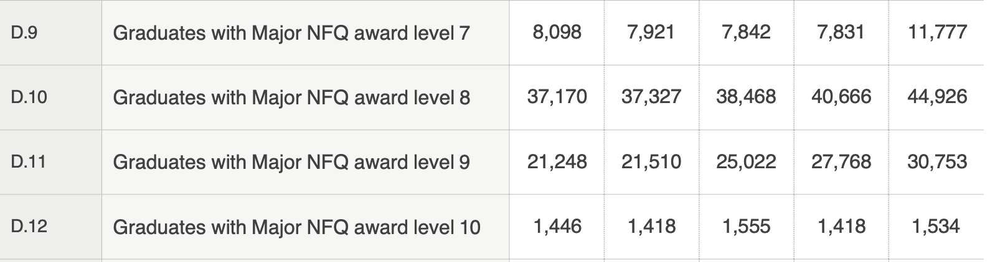

Figure 1. Graduating student numbers for levels 7-10 in Ireland from 2017 to 2021. From "Education Indicators for Ireland February 2023" by Government of Ireland, Department of Education and the Department of Further and Higher Education, Research, Innovation and Science, 2023, <https://www.gov.ie/en/publication/055810-education-statistics/>

## Reasons for Target users Studying Data Science

According to the News Release from the Bureau of Labor Statistics (2023), the position of Data Scientist is ranked as the 3rd out of the 10 fastest-growing occupations from 2022 to 2032, as shown in Figure 2(Bureau of Labor Statistics, 2023). Given this information, inferring students' heightened interest in data science is plausible.

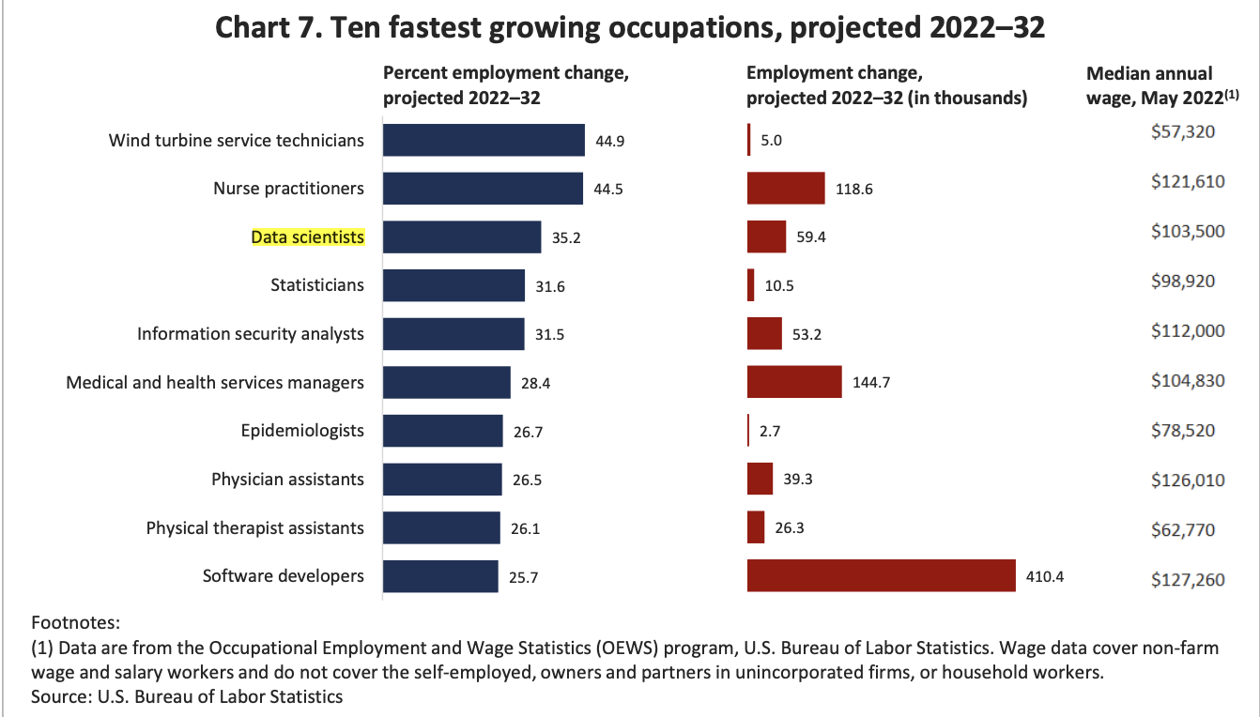

Figure 2.Ten fastest growing occupations, projected 2022-32 in the United States. From "EMPLOYMENT PROJECTIONS — 2022−2032" by Bureau of Labor Statistics, 2023, <https://www.bls.gov/news.release/pdf/ecopro.pdf>.

## User Personas

Due to the rise of students in Ireland and the rise in popularity of data science positions, we have identified our product niche to cater to Data science students. Here, you can see their Goals, Motivations, Frustrations and, most importantly, a use case on how Data Polish could help them in their master Journey using a fake example persona

.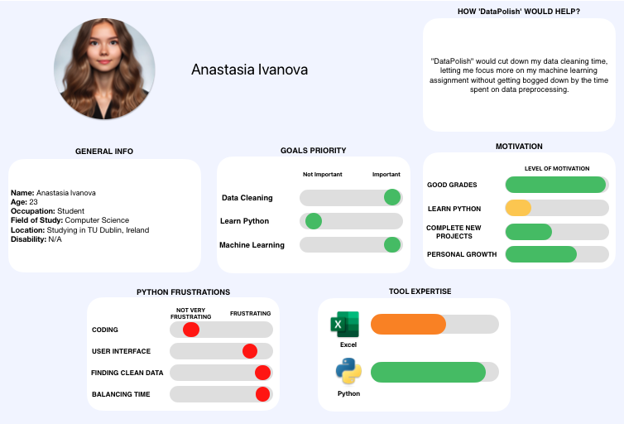

Figure 3.Students’ user persona.

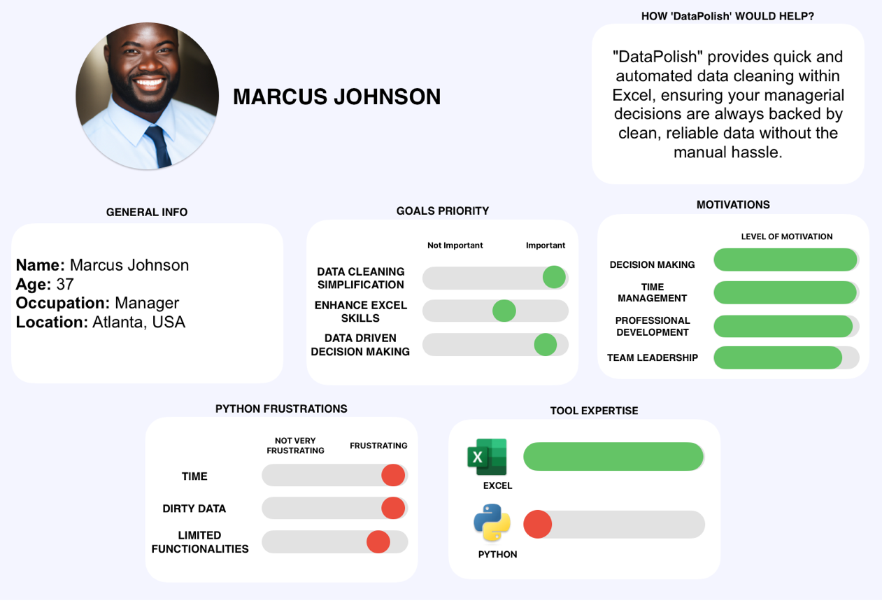

Figure 4.Non-Technical Business user persona.

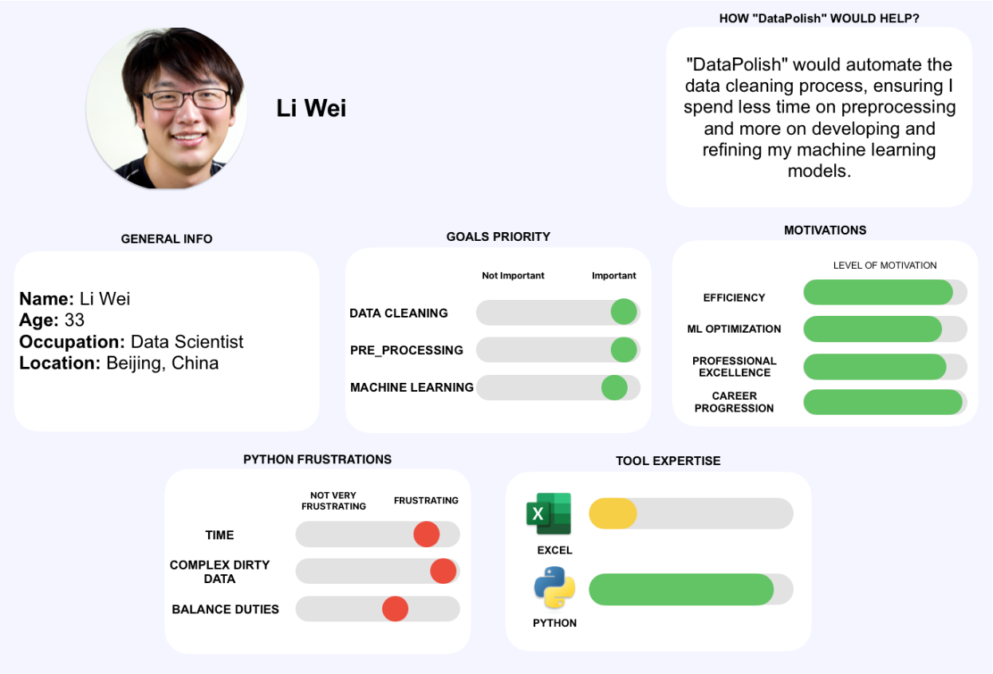

Figure 5. Technical Business user persona

The figures Figure 3, Figure 4, and Figure 5 show the three distinct personas we have identified. Specifically, Figure 3 represents our focus: the Data Science Student. The subsequent figures delineate the other two: Figure 4 captures the non-technical business user, while Figure 5 highlights the technical one. Given our position as a student-created and student-driven tool, our insight into the student persona provides a unique advantage. This understanding is more intuitive than trying to grasp the nuances of a full-time professional's perspective.

## Problems for target users

Data cleaning is not just an ancillary step in data analysis; it is its backbone, demanding meticulousness and time. As Haas et al. (2015) highlighted, analysts often find a staggering 80% of their time consumed by this phase alone (Haas et al., 2015, p. 2005). The implications are clear: Data cleaning is not merely a task but a linchpin for efficient data processing. It thus emerges as a significant avenue for time-saving. Our aim with Data Polish is to respond to this challenge head-on. We aim to streamline this arduous process by offering rapid data profiling that illuminates anomalies and inconsistencies within datasets. More than just identifying these issues, Data Polish proposes solutions, guiding users through steps to rectify and optimize their data. The outcome? A dataset that is not only clean but also more accessible and digestible. In doing so, we aspire to gift our users what they value most: time.

Data cleaning may seem simple, but it comes with many problems. A study using the Kaggle dataset and Eurobarometer survey data showed issues like dealing with missing values, errors in software like RStudio, and handling tricky textual data (Murphy, 2023). The study also pointed out that it can be hard to manage if we divide data too early. Another challenge was changing data into a suitable format, like making sure dates were correct. We also had to be careful when mixing data titles from different years.

This insight shows that data cleaning is more than just a first step; it is essential and complicated. Doing it right can help researchers turn primary data into valuable insights.

## Survey feedback

Before we knew our end user, we ran a test survey to identify the interest of our application on LinkedIn, In the end, we achieved 24 responses, here are the results.

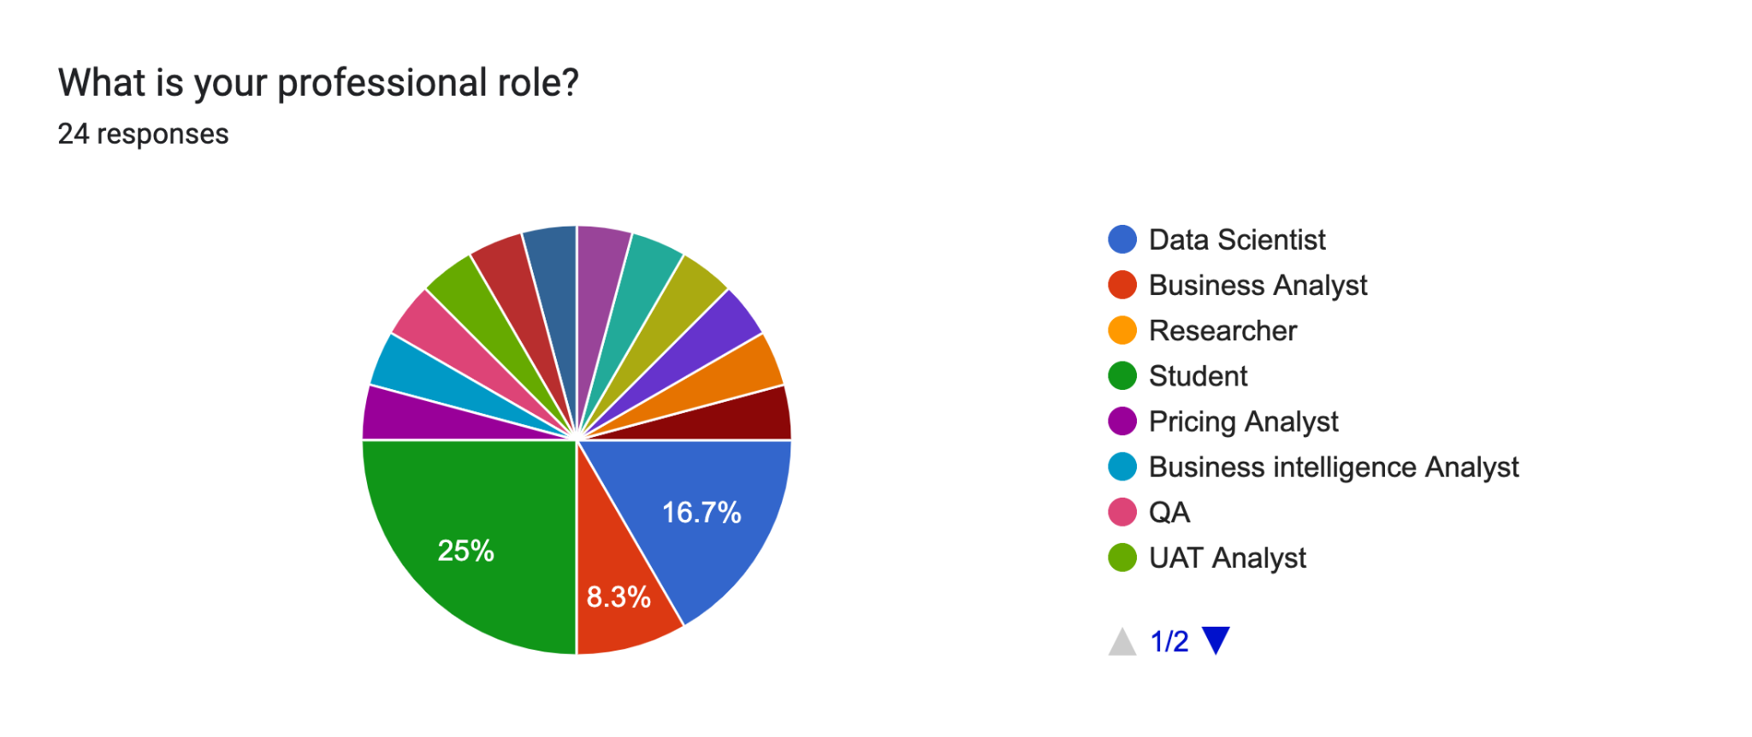

Figure 6. Pie chart of the professional Role Distribution

As seen in Figure 6, We identified that ¼ of our results came from students.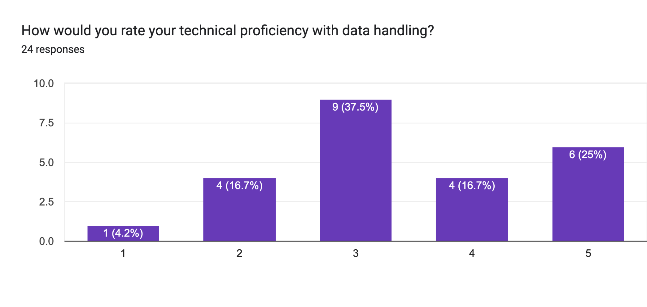

Figure 7. Bar chart of the technical proficiency with data handling Distribution

Here in Figure 7, we asked about the proficiency of their coding abilities to get an idea of how skilled our users on average are, to which we can see a high number of people with high to medium proficiency.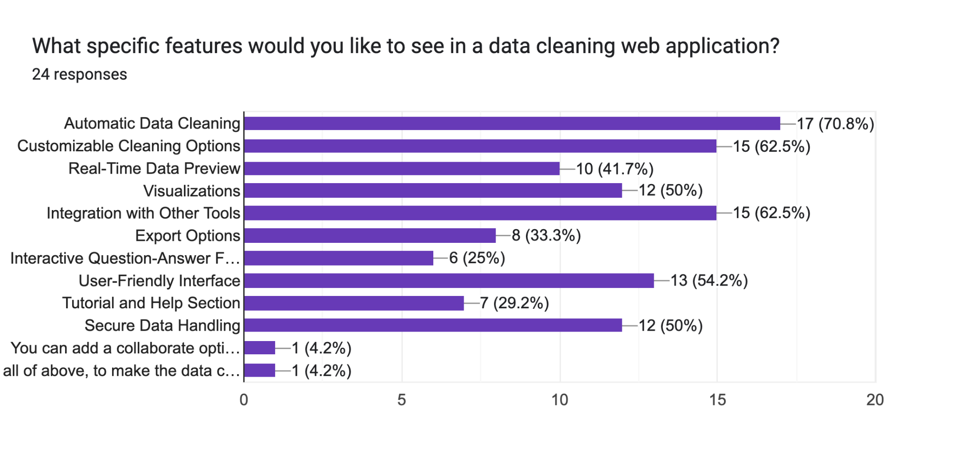

Figure 8. Horizontal bar chart of the feature importance from our users.

Next in Figure 8, we aimed to identify some of the Key Initial features the end user searched for in a data-cleaning application.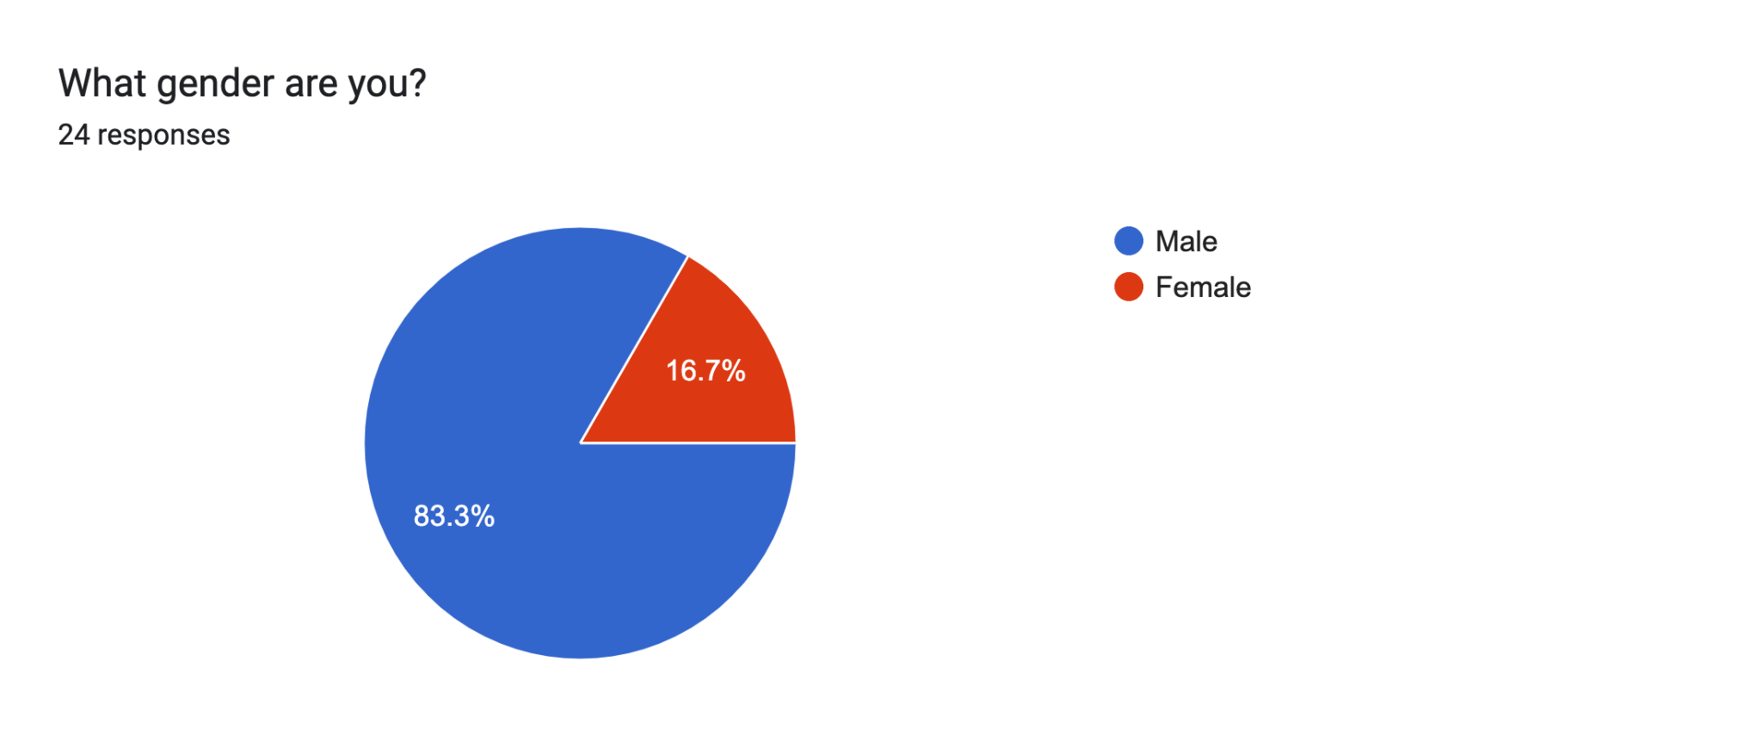

Figure 9. Pie chart of the gender Distribution

In Figure 9, although the survey was very limited, we wanted to see if our gender had an impact.

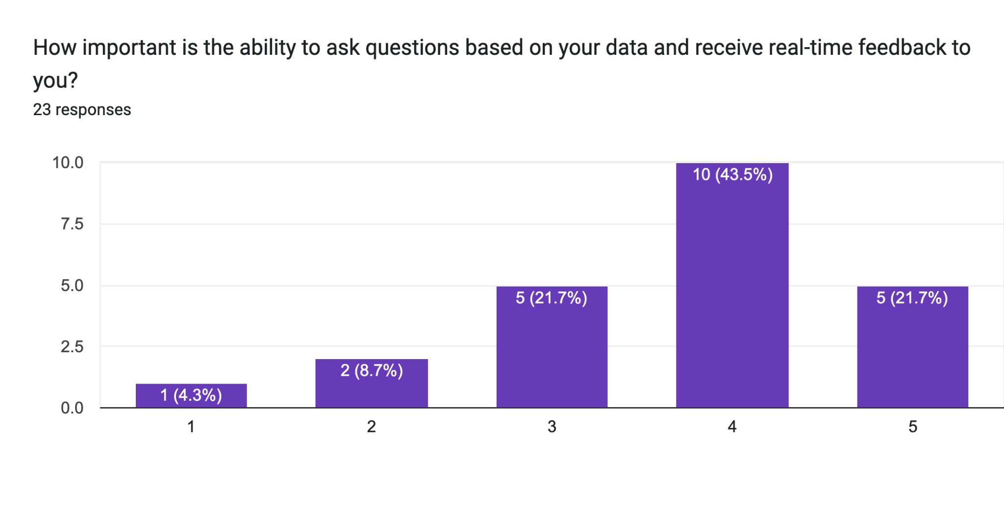

Figure 10. Bar chart of the importance of data profiling ranging from 1-5

In Figure 10, we identified the importance of information gain people are expecting from a data cleaning tool. This was the main reason for our initial key feature of data profiling having an interactive element.

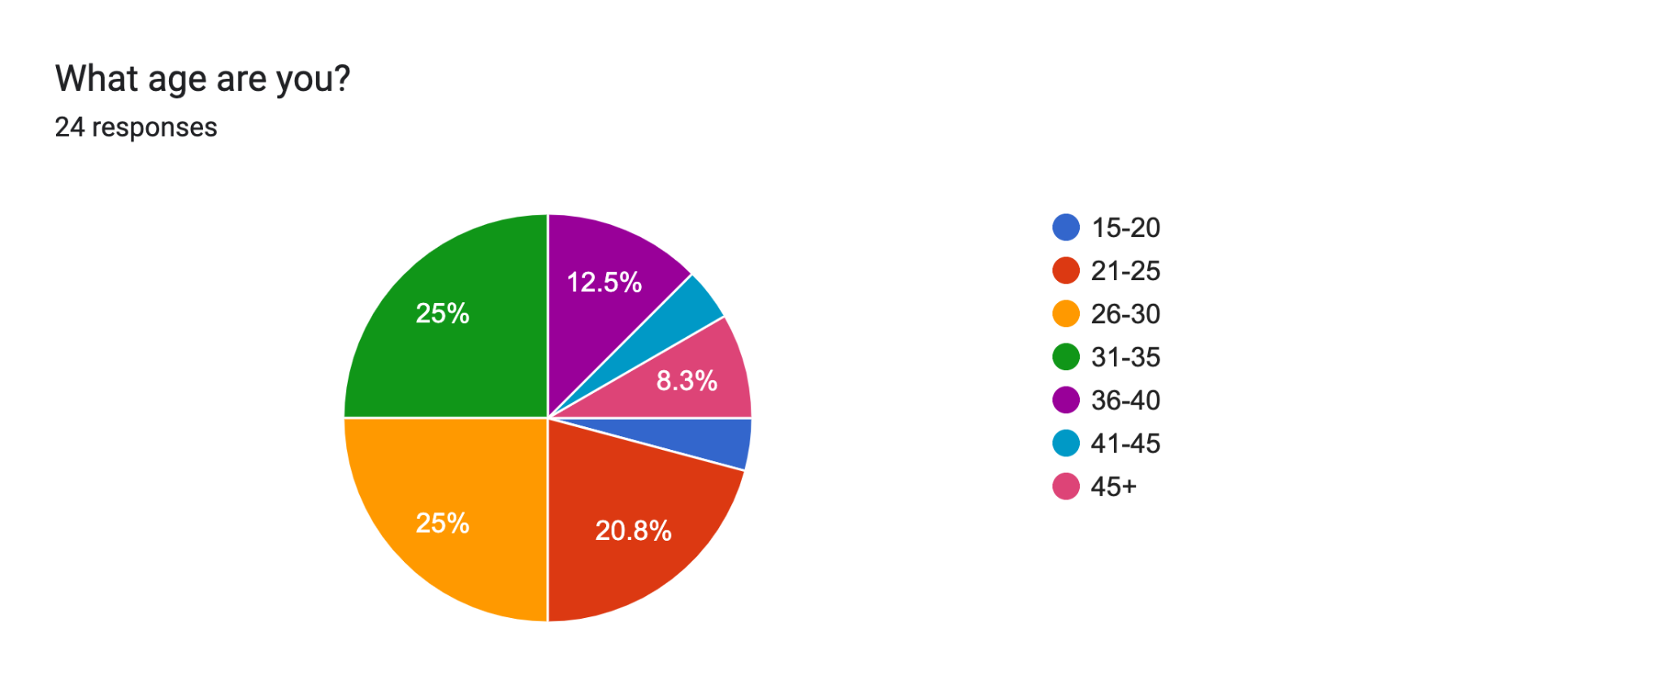

Figure 11. Pie chart of the age distribution of interested users.

Finally in Figure 11, based on our pie chart shown we can see that the love for data seems not to have a age restrictions making our tool versatile especially when it comes to a large range of ages expected in an academic environment.

## Benefits of Our Product for Institutions and Data Science Students

The challenge of data Science is not merely in interpreting clean data but in managing and rectifying dirty data. Detecting and repairing such "dirty data" are persistent challenges and, if overlooked, can lead to flawed analytics and misguided decisions (Chu et al., 2016, p.4). Their research underscores a significant increase in interest from both the industrial and academic sectors in recent years. They discuss the exploration of new abstractions, interfaces, and scalability approaches to address the myriad facets of this problem. This mounting interest from academia suggests a ripe opportunity. Universities and their students actively seek solutions to these data cleaning challenges, positioning "Data Polish" as a relevant and crucial tool in this expanding market.

## Interviews

The responses from our initial survey could have been more satisfactory, prompting us to delve deeper into options for obtaining qualitative data. The purpose was to understand our target audience's genuine needs and preferences. "From this study, the researcher would advocate for employing interviews as a data collection instrument in preliminary qualitative research" (Jain, 2021, p. 552). Jain (2021) further emphasized that, although time-consuming, surveys are preferable to procure qualitative data to bolster our product research. Based on the GitHub recordings, our findings indicated that student users desire a tool like Excel to process and prepare data, primarily for efficiency (GitHub, 2023). This input further illuminated the core functionalities our users anticipate from our software, encompassing elements like statistical significance, feature reduction, and handling categorical attributes, such as dummy variables.

## Conclusion

Our research shows many challenges in data science, especially in cleaning data. With more people interested in studying in Ireland and many universities worldwide wanting to work in data science eventually, we have a big chance. Alex Murphy's work mentioned in the problem section showed us the data from Kaggle and Eurobarometer shows how vital and challenging data cleaning is, highlighting the need for a tool like Data Polish (Murphy, 2023). Our surveys and online interviews with people confirmed this: Students want a tool that's easy to use but also does its job well.

This opportunity is where Data Polish comes in. We are focusing on students because we know what they need – we are students, too. We wanted to make something that helps students and meets the high standards of professionals. In schools and universities, where people of all ages are eager to learn, Data Polish is not just a tool but a friend. As we move forward, we are not just trying to fit in. We want to set a new standard.

# Technical Problem

The product to be developed, a data cleaning tool, is designed to create a robust and user-friendly tool that streamlines the process of cleaning, transforming, and analyzing datasets. The system will address a host of data cleaning and quality challenges.

## Rationale Behind Need for the System

Data sets are often marred with diverse quality problems like duplicates, missing values, violations of integrity constraints, and outliers. Identifying and rectifying these issues requires a systematic approach that a data cleaning tool like this provides (Chu, Ilyas, Krishnan & Wang, 2016). The initial phase of error detection involves spotting anomalies or mistakes in a database. Given the intricacies of qualitative error detection, the tool must address what types of errors to look for, how to detect them, and where these errors are most likely to occur (Chu et al., 2016). As errors are identified, the next step is to repair them. The tool must decide what to repair (data or constraints), how to execute the repair, and where the repair needs to happen (Chu et al., 2016).

Data often undergoes numerous transformations due to structural changes, schema evolution, system migration, or integration of multiple data sources. Each scenario presents unique challenges, such as naming conflicts or differing data representations, requiring systematic cleaning processes (Rahm & Do, 2000). Data originating from a single source can have quality issues, primarily if limited constraints exist on what can be entered and stored. These issues can be due to the lack of schema, inadequate data model restrictions, or poor schema design, leading to errors and inconsistencies at both the schema and instance levels (Rahm & Do, 2000). These are more pronounced when integrating multiple data sources. Independent development and maintenance of these sources lead to heterogeneity, resulting in conflicts and inconsistencies at schema and data levels. Problems include naming conflicts, structural conflicts, differing value representations, and various data conflict types at the instance level (Rahm & Do, 2000).

A significant challenge in cleaning data imported from multiple sources is identifying overlapping data and precisely matching records that refer to the same real-world entity (Rahm & Do, 2000). A data cleaning tool is needed to eliminate duplicate information and consolidate complementing information for a more consistent view of instances referring to a similar entity (Rahm & Do, 2000). Data cleaning needs to be reactive and proactive, requiring tools to help design appropriate database schemas and integrity constraints. This measure usually helps to prevent the entry of ‘dirty data’, reducing future cleaning requirements on the dataset (s) (Rahm & Do, 2000).

## Core Technical Problems

### 3.2.1 Overview

In this section, we acknowledge and address fundamental technical challenges that arose during the development of our application, offering insights into how these issues will be effectively resolved as we progress further in the application's development.

### 3.2.2 Seamless and Inclusive User Experience

In our journey to develop a web application primarily tailored for students, one of the main technical problems was the imperative to deliver an outstanding user experience.

Given our student-centric target audience, it was important to ensure that the application is exceptionally user-friendly, engaging, and accessible. We wanted our application to have a very easily understandable UI so that it could be effortlessly navigated by users with varying levels of expertise. This demand for user-friendliness encompassed not only functional elements but also visual engagement.

Moreover, accessibility stood as a critical aspect of our design. We were committed to ensuring that students with diverse needs, including those with disabilities like visual impairments, could effectively and comfortably use our application.

Introducing an interactive data profile dashboard, a unique feature distinguishing our application from existing tools, added an additional layer of complexity. Our goal was to create an enjoyable and insightful user experience, which required meticulous design and implementation.

### 3.2.3 Backend related Problem

An unexpected file management issue surfaced within our system when user-initiated file uploads with identical names. This unintended behaviour resulted in file snapshots or, in some cases, overwriting in the blob storage, posing a risk to data integrity. To mitigate this issue, we devised a solution that involved integrating EPOCH timestamps, effectively preventing file overwrites and eliminating ambiguities associated with identical file names. These timestamps, denoting the number of seconds elapsed since January 1, 1970, offered a unique identifier for each uploaded file, ensuring that data was distinct and comprehensively organized (Epoch Converter, 2010).

Another problem was a mismatch in SSL configurations within our application. While the users attempt to access the APIs over HTTPS by default, our application lacks SSL support. This disparity disrupts the communication flow, preventing users from successfully connecting to the APIs. It is imperative to rectify this SSL mismatch to re-establish secure and functional access to the APIs.

### 3.2.4 Deployment and Hosting related Problem

We encountered a challenge regarding loading logos and other static assets post-deployment. We were getting a 404, and it became apparent that in Angular, we needed to navigate from the current file directly to the assets folder for assets folder access. This meant using paths like 'assets/images/img.png' instead of the previously attempted '../../assets/images/img.png.' This issue was due to the complexities of Angular's asset folder structure, requiring a deep understanding to navigate a solution. We researched the specifics of this issue and its resolution, with further insights available in the article (Images Not Loading from Assets Folder in Angular, n.d.).

Afterwards, while building our production application, we were getting errors. To fix we had to increase the budget of our application in terms of size (Gudelli, 2023). 

Figure 12. Screenshot of the error encountered.

When we tried to deploy our Spring Boot application on AWS, we faced some unexpected problems because of the version of Java we were using, which was JDK 21. This caused trouble for our application and other apps running alongside it, like the Tomcat server. This mix of technologies that did not quite match led to our application failing to deploy correctly, causing issues in how it worked. It reminded us how important it is for all the technologies we use to work well together. To solve this, we had to carefully rethink our Java Development Kit and make some changes to ensure our Spring Boot application could work appropriately with the deployment system.

The deployment of a Spring Boot application onto a Tomcat server posed a distinct set of technical challenges, prominently among them being the choice between JAR and WAR packaging. Initially, our project was configured with WAR packaging, a prerequisite for deploying within the Tomcat environment. However, this decision caused our application to fail to start correctly. We had to switch from WAR packaging to the more suitable JAR packaging to fix this. This taught us how important it is to choose the right way to package our application from the beginning to avoid problems later in the project.

While setting up Python on our server, we ran into a problem. The solution was simple - we just needed to update a package we had forgotten about ([Ubuntu] Error While Using Apt-Get Install [Archive] - Ubuntu Forums, n.d.). However, it took us a whole day to determine the problem. This experience reminded us that even minor oversights can cause significant delays when setting up a server.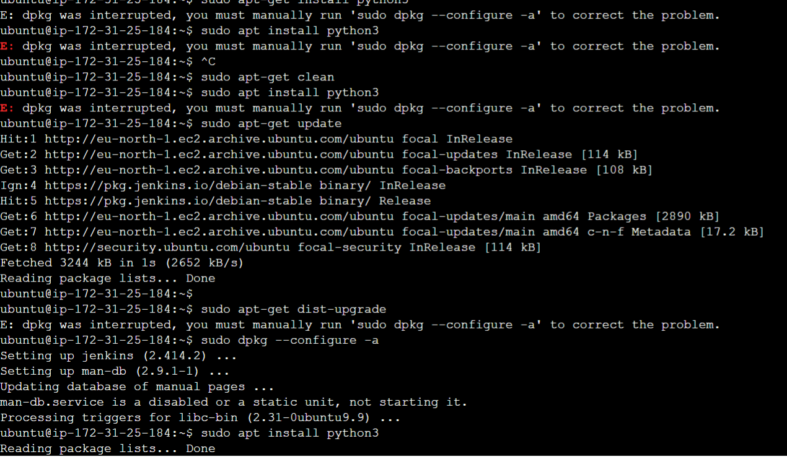

Figure 13. Python package update issue

The last core technical problem we encountered was initially selecting the Amazon RDS Oracle Database for our application. After a few days, we received an unexpected bill for this database in our AWS account. This unexpected cost arose from an oversight in selecting the free database option suitable for the AWS free tier. To resolve this issue and align our expenses with our free tier usage, we were compelled to migrate our database to a free alternative within the AWS free tier, ensuring that our application remained cost-effective and compliant with our budget constraints.

## Other Existing Similar Systems

There are a plethora of data cleaning tools that could be deemed as our competitors. However, for the sake of brevity, two of the more well-known data cleaning applications will be discussed with their merits (how they meet user needs) and demerits (how they fall short of user needs highlighted)

Oracle Analytics, about its desktop application, is a tool that allows processing datasets from various sources to allow its users to make decisions and evaluate predictions based on data. It can be found here <https://www.oracle.com/ie/business-analytics/#:~:text=Offering%20valuable%2C%20actionable%20insights%20from,Explore%20Analytics%20products>

Pros of the Oracle Analytics desktop app:

* Its Data Visualization features allows it users to create rich visual representations of data from various sources. It offers a wide range of charts, graphs, and tables to help users understand their data.
* It considers business users and provides them with the ability to analyse data without relying heavily on IT. Users can drag-and-drop data, create calculations, and produce insights.
* It's data Integration allows the app to connect to a range of data sources, from local Excel spreadsheets to databases and cloud applications. It can blend and transform data from various sources to provide a unified view.
* Its advanced analytics allows the app go basic visualization and offer machine learning tools to enable features such clustering, forecasting and enabling deeper insights.
* Its users can create their analyses or reports which they can share s with others aiding decision making.

Cons of the Oracle Analytics desktop app:

* Its comprehensive nature makes for a steeper learning curve for features, especially when compared to more intuitive, plug-and-play analytics tools. Particularly since it uses a lot of SQL syntax to make transformations to columns it is not very beginner friendly.
* The mac desktop version is loaded with a myriad of technical deficiencies and couldn't import CSV files, which serves as a significant concern since many datasets are in CSV's.
* Oracle solutions are known to be on the pricier side, especially for small to medium-sized businesses. The licensing and maintenance costs can be a barrier for some organizations particularly the cloud suite of the analytics tool.
* Some users have reported challenges when connecting to non-Oracle sources or third-party tools.

Open Refine (formerly Google Refine), its desktop application, can help transform datasets into other formats or perform transformations on the dataset itself, depending on the user's choice. It can be found here https://openrefine.org/

Pros of the Open refine desktop app:

* Open Refine records all changes applied to the data, allowing users track and copy changes to another dataset if needed.
* It can handle large amounts of data instances efficiently, allowing users to process and clean data that would be cumbersome in traditional spreadsheet software.
* It can allow a variety of transformations and conversions from one data format to another.

Cons of the Open refine desktop app:

* Legacy UI feel as its kept much of its original UI from the original google refine application.
* It does not support advanced data visualizations.
* It is not built to perform complex statistical analysis.
* It does not integrate directly with data storage systems (databases)

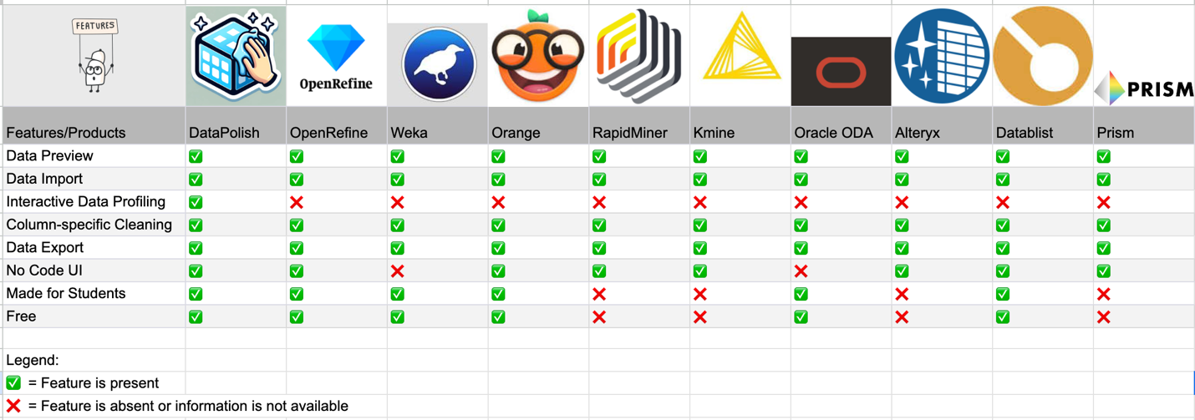

Figure 14. Comparison Matrix of similar systems and their features

# 4. Technical Solution

## 4.1 System overview

Data Polish is a web-based application primarily for students who want to perform data science on datasets. Our application aids by cleaning datasets before any machine learning or deep learning techniques are performed on their dataset. This application has a straightforward user interface, which is easy to operate.

## 4.2 Initial Design Documents

To outline the core functionality and features of our system, we have developed preliminary designs to provide a comprehensive overview of the application's purpose and capabilities.

### 4.2.1 Overall System Flow

Below is a high-level of the system flow of our application:

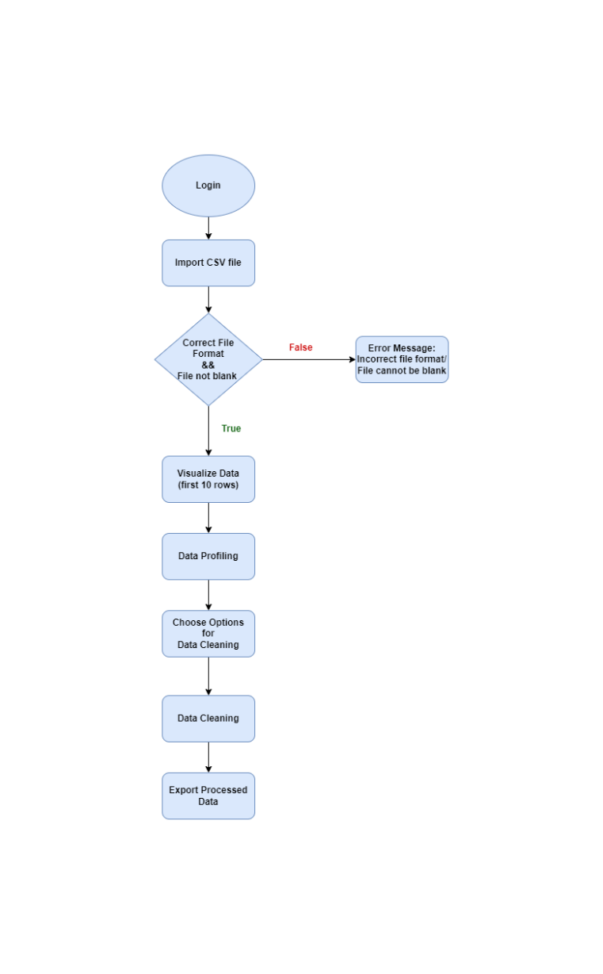

Figure 15. Overall System Flow Diagram

### 4.2.2 Use Case Diagram

Next, we designed a high-level use case diagram as shown below:

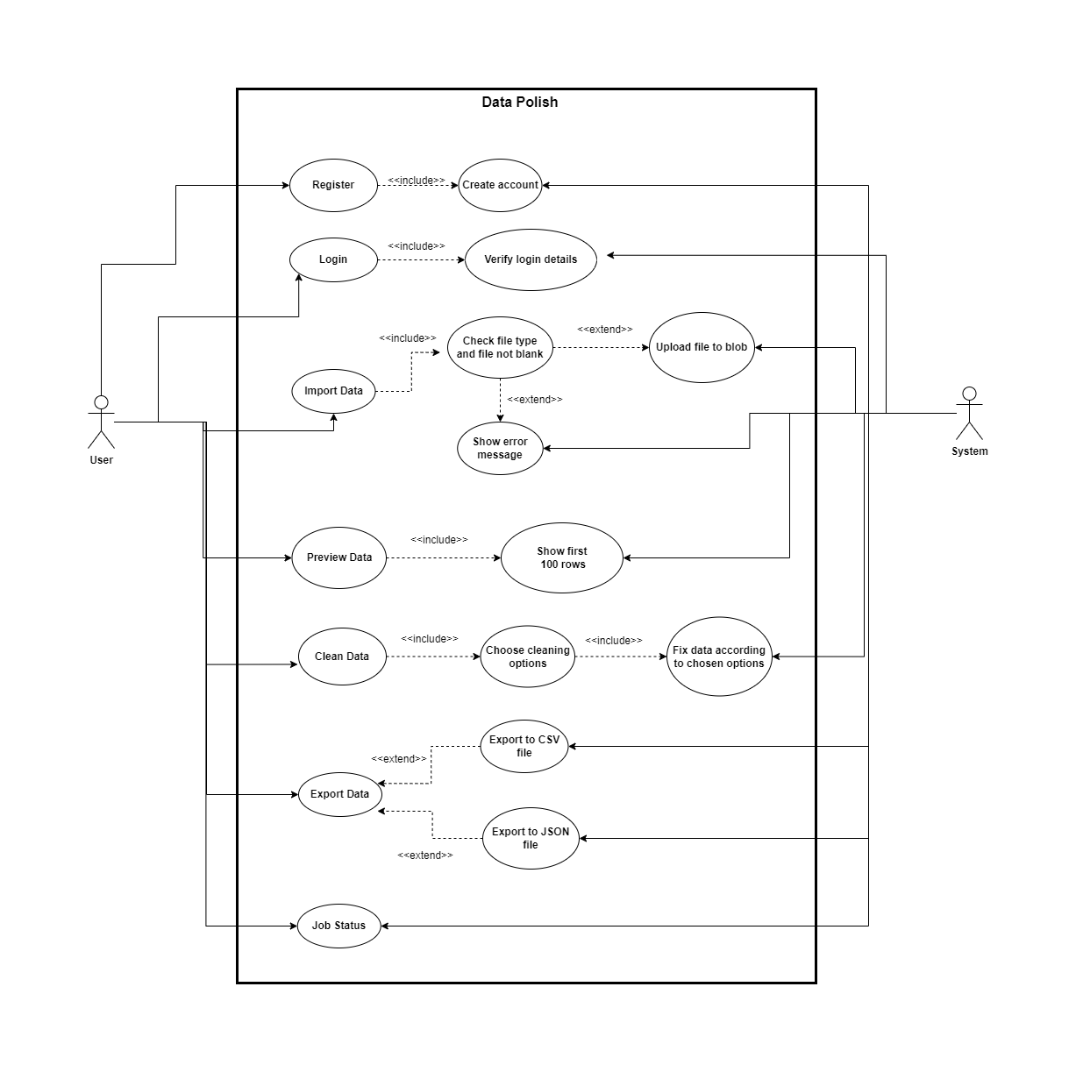

Figure 16. Use Case Diagram

### 4.2.3 Planned Site Map

The site map diagram attached below shows a hierarchical view of the pages on our web application, starting with the home page at the top.

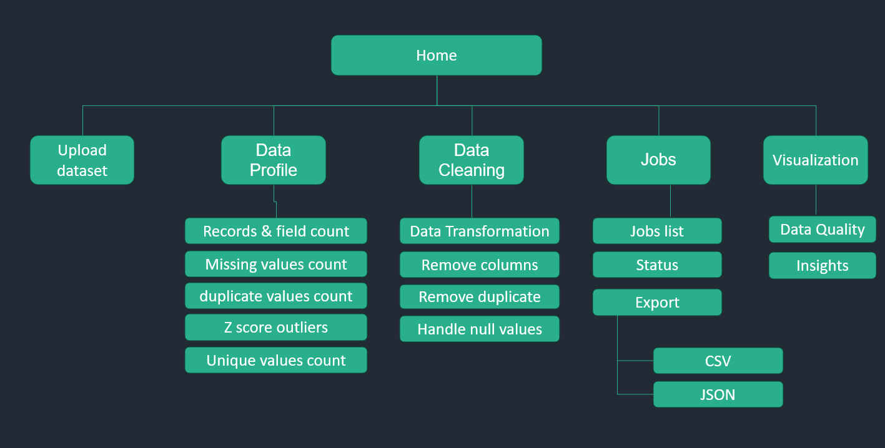

Figure 17. Site Map

## 4.3 Prototypes of Main Features

We have used Lucid Chart to create the initial mock-ups or medium-fidelity prototypes of five pages for the main features. The 'Data Preview/Visualization' page has not been implemented yet; its execution planned for the next release.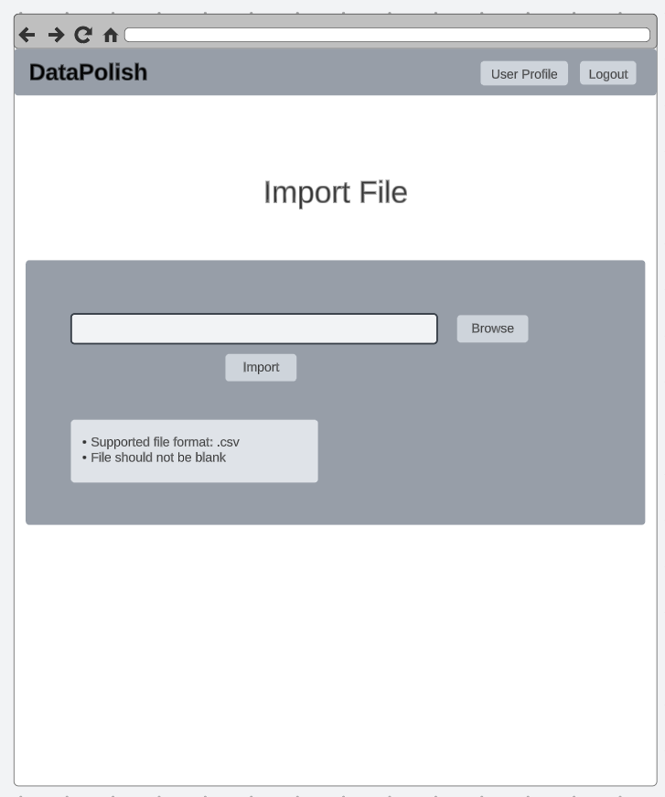

Figure 18. Prototype of File import page

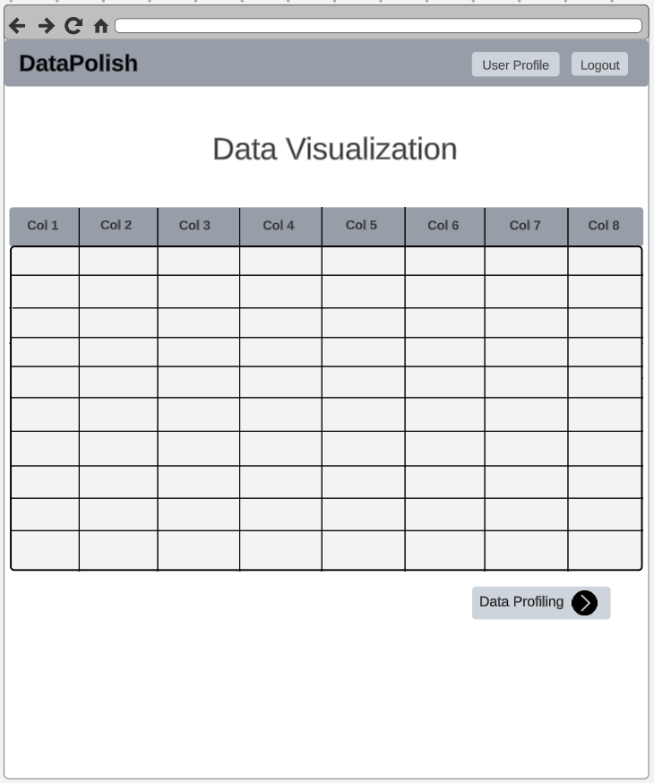

Figure 19. Prototype of Data preview page

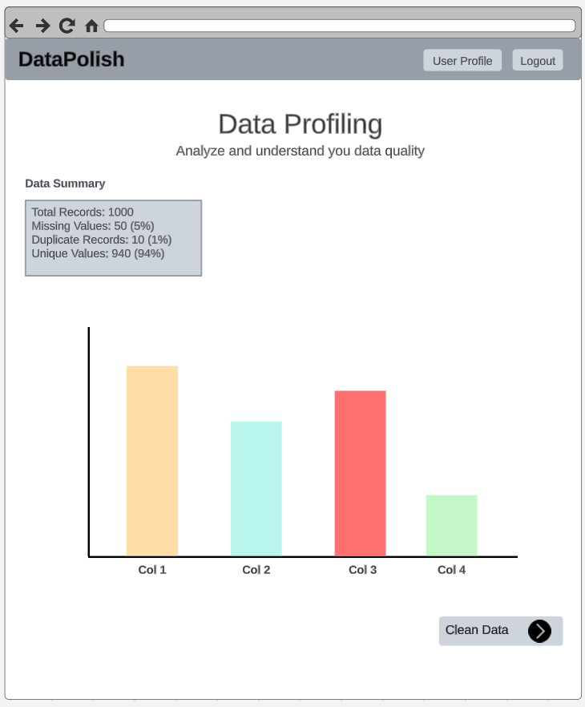

Figure 20. Prototype of Data profiling page

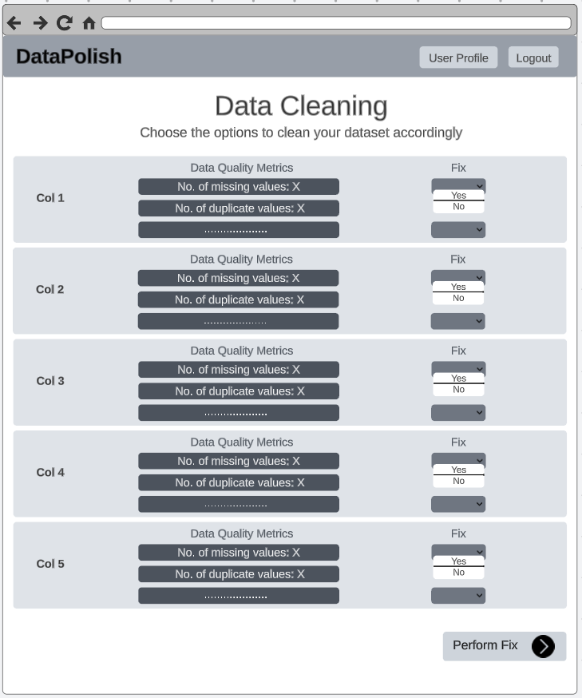

Figure 21. Prototype of Data cleaning page

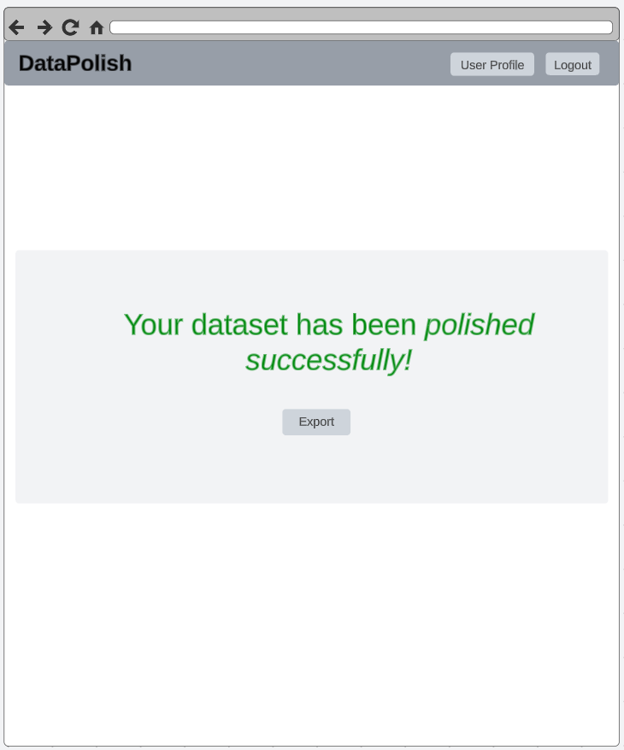

Figure 22. Prototype of File export page

## 4.3 Breakdown of Key Functionalities

This section contains descriptions of the key features we have implemented so far, along with screenshots of the relevant page of the application.

### 4.3.1 Data Import

To start with the ‘Data Polish' journey, the end user must first upload their dataset on the application. They can upload their file using the drag-and-drop feature on this page. Also, using the '+ Choose' button, they can browse their device to upload the file. We are currently accepting .csv file formats only, but we plan to include more file formats in upcoming releases. After choosing the file, the user can click the 'Upload’ button to upload it or click' Cancel' if they have chosen the wrong file. It will be saved in the cloud, and the user will get a unique ID (job ID) to track the progress of their work.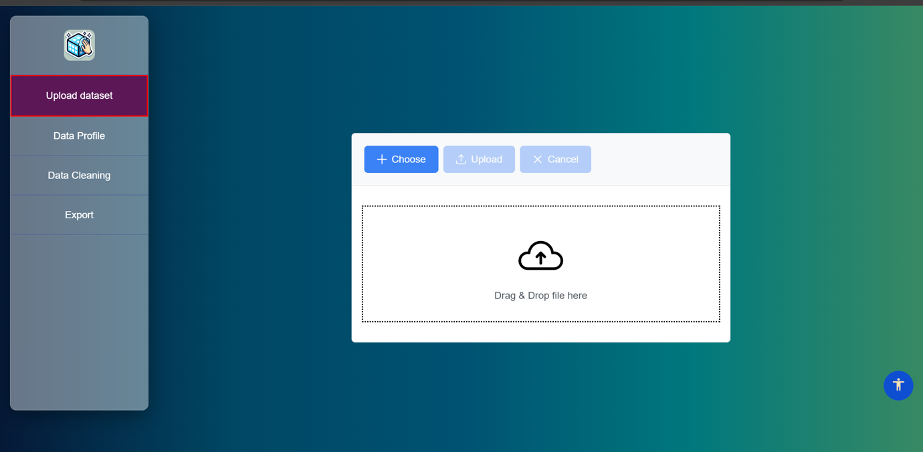

Figure 23. Screenshot of data uploading page from 'Data Polish' application

### 4.3.2 Data Profile

On this page, the end user will be able to get the current data quality index and complete profile of the dataset they have uploaded. This will show some analysis of their data quality, which will help them understand their issues. By clicking on the 'Missing Values', 'Outlier - Scatter', 'Outlier – Table' and 'Unique Values', users can check the analysis presented in those diagrams which pop up when they click it. We plan to replace this page with an interactive dashboard next month.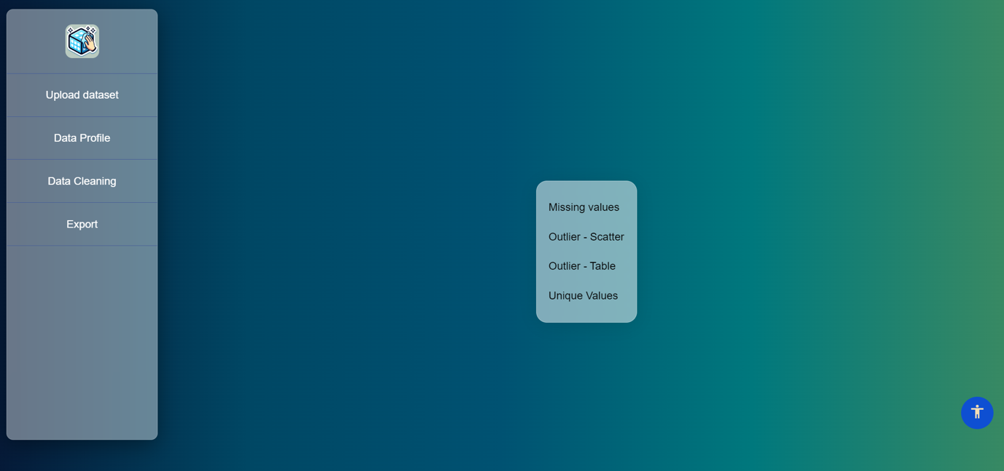

Figure 24. Screenshot of data profile page from 'Data Polish' application

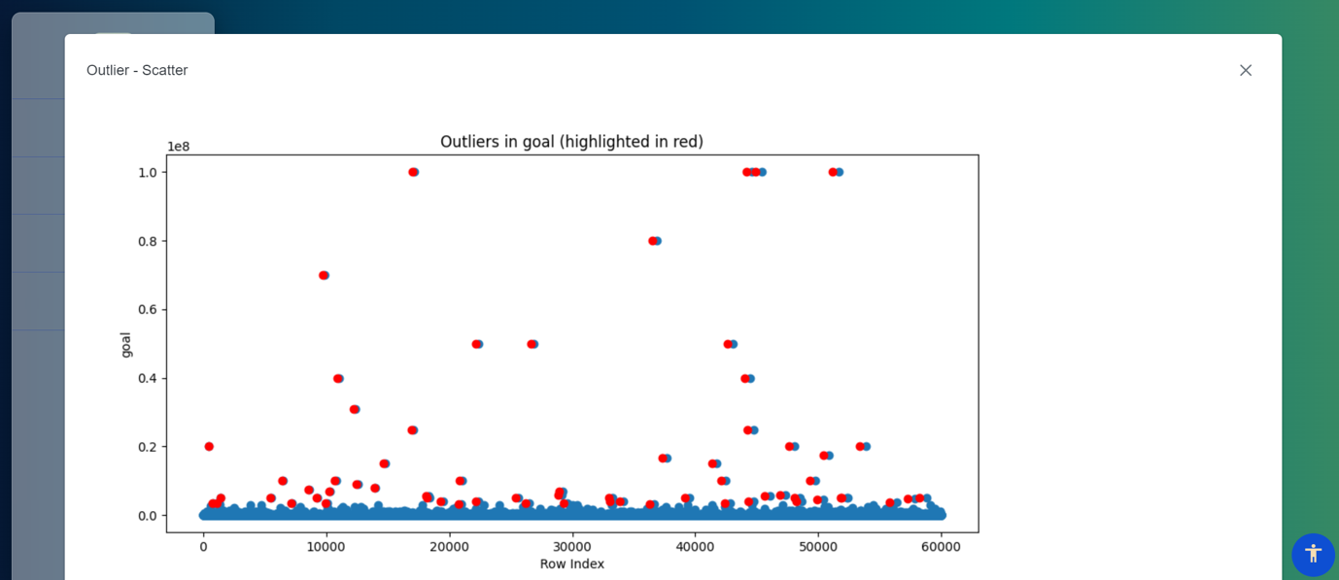

Figure 25. Screenshot of pop-up page showing outlier-scatter from 'Data Polish' application

### 4.3.3 Data Cleaning

On this page, the end user can click the button to initiate the data cleaning process in the backend. For now, there is only this button on the page, and we are only removing duplicates from the dataset as part of the cleaning process. In upcoming releases, however, we will give the user the flexibility to choose which columns and data cleaning options they want the application to perform or keep as it is. This feature is referred to as 'Column Specific Data Cleaning'.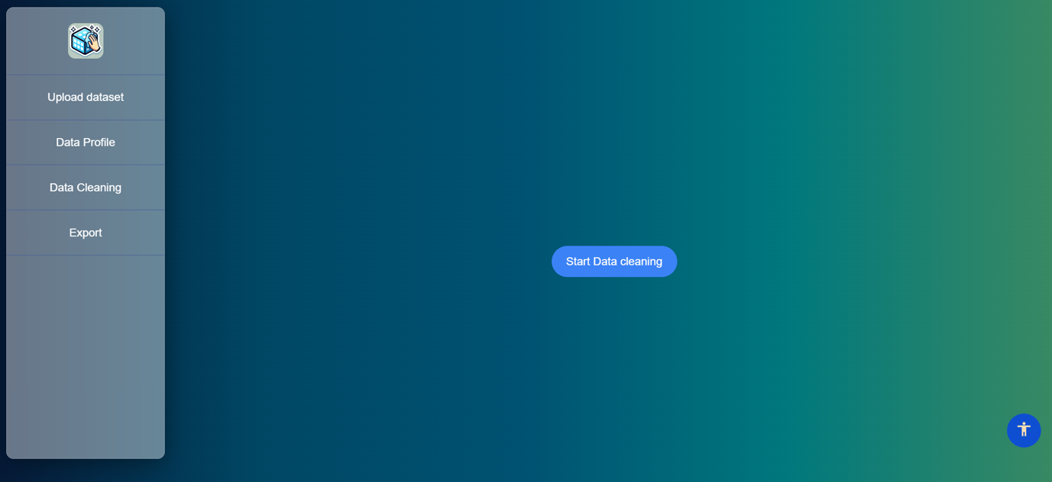

Figure 26. Screenshot of data cleaning page from 'Data Polish' application

### 4.3.4 File Export

On this page, users can enter the Job ID they received from the application after uploading the file and check whether it has been cleaned by clicking the 'Check Status' button. If the data cleaning process of that file is completed, they can download the cleaned data file by exporting it as a CSV file.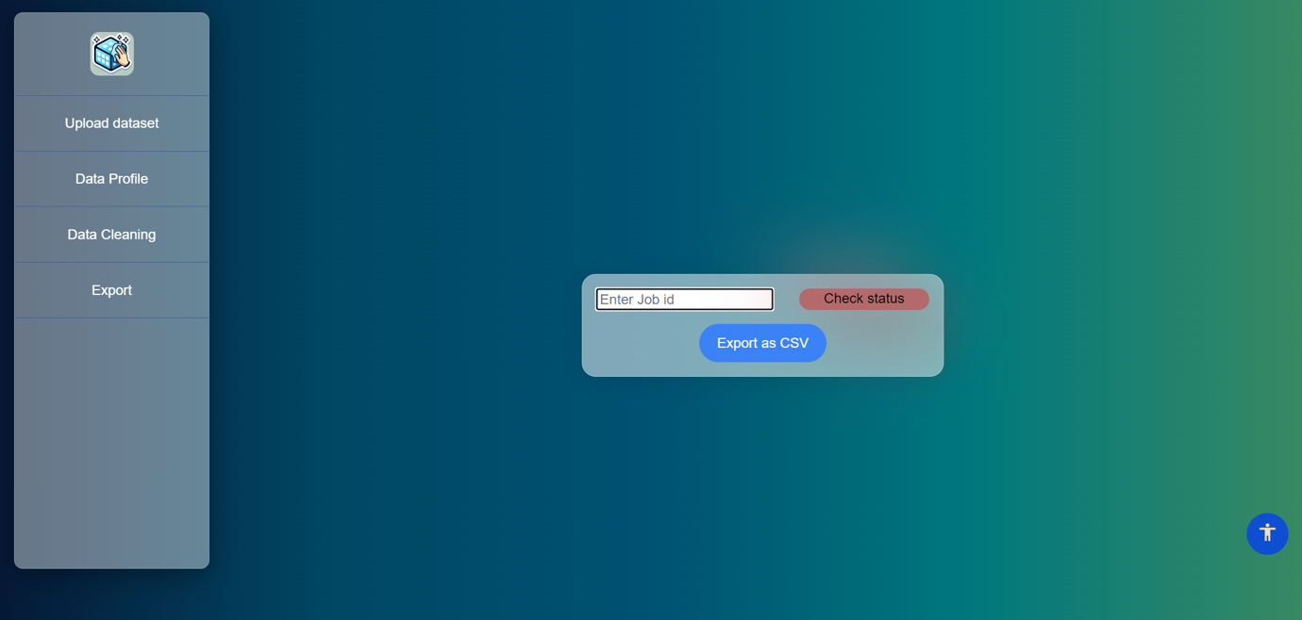

Figure 27. Screenshot of file downloading page from 'Data Polish' application

## 4.4 Systems Architecture

This section offers a comprehensive insight into our system architecture, encompassing the high-level structure and an in-depth exploration of each main feature's technical components and the flow between them.

### 4.4.1 Overall Systems Architecture

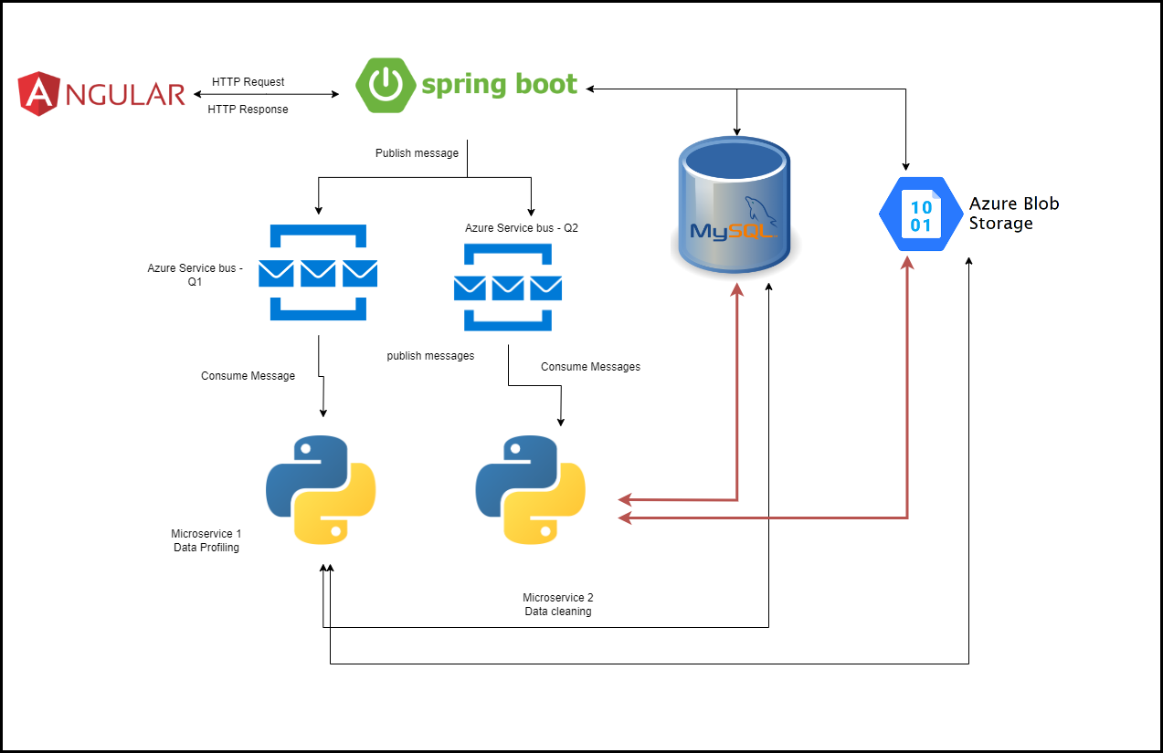

Figure 28. Overall systems architecture diagram

We are developing a modern web application using a stack that includes front-end technologies like Angular, Bootstrap, and Prime NG (framework) for the user interface. We are utilizing Java, Spring Boot, and Maven on the backend to build our APIs. Our data is stored in a MySQL database, and we use Azure Storage Account's blob storage for file storage. For data profiling and cleaning, we have integrated Python into our application.

Users interact with the application using our Angular front-end interface. Angular app sends a HTTP Request to the spring boot API, which can query the database for any required information and put a message into the queue stating what it needs. Afterwards, the Python application takes the message from there, processes and stores data files in blob storage.

### 4.4.2 Cloud Deployment Architecture

Once the system architecture was fixed, the primary application was also developed to be hosted. While hosting, we faced several issues and had to change the architecture multiple times to ensure robust integration between services.

To keep up with the learning curve, the need for complex deployments, the need for multiple environments to test code and limited cloud resources, we decided to use AWS EC2 – Ubuntu server running tomcat server for spring boot application, angular applications and other python services are deployed as daemon services in the same server.

For the database, we are using AWS RDS service with MySQL engine. We are taking advantage of the Microsoft Azure service bus for the messaging system, and for storing binary files, we are using Microsoft Azure Storage Account Blob Storage.

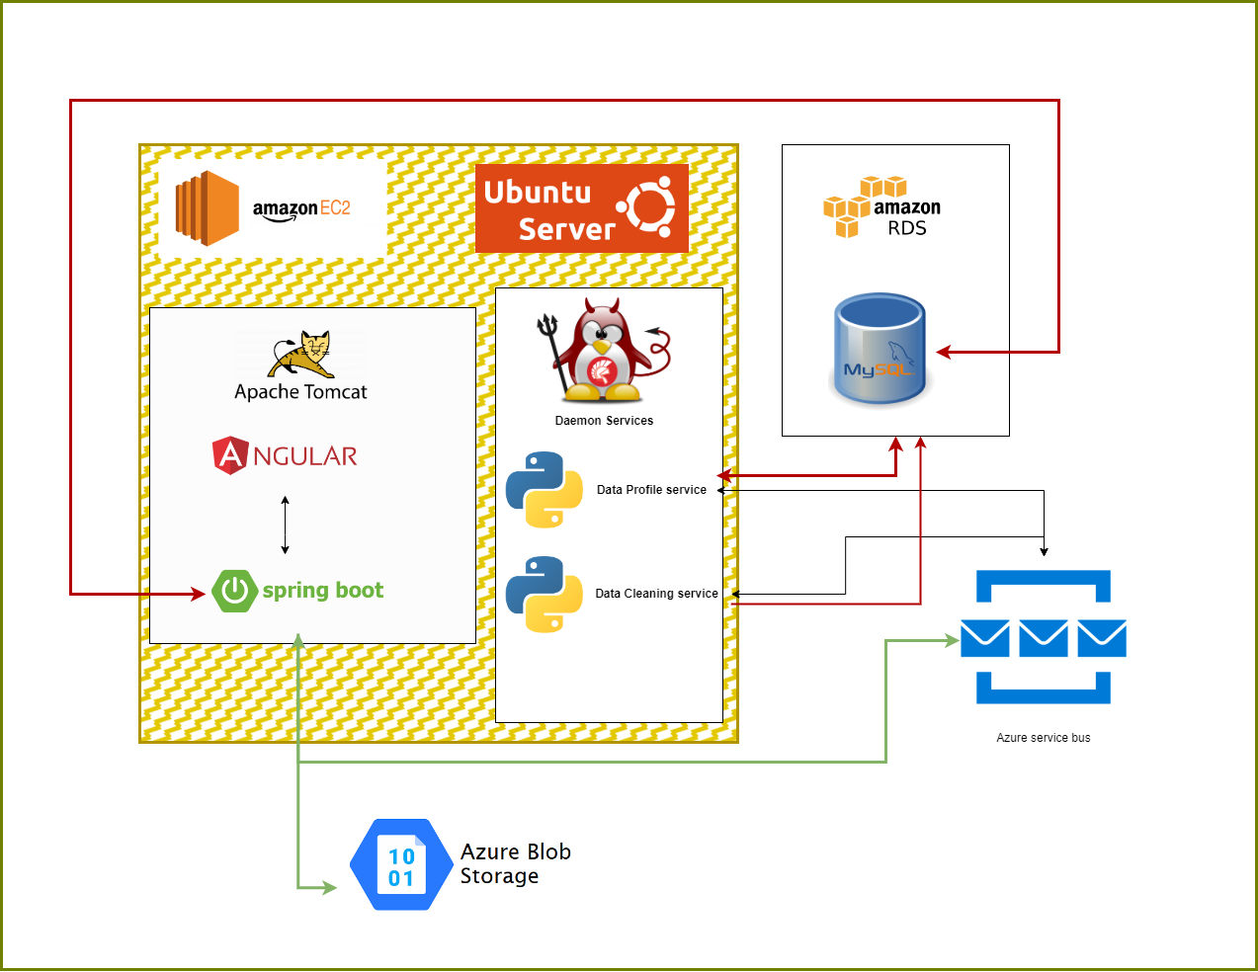

Figure 29. Cloud deployment architecture diagram

### 4.4.3 Systems Architecture – Main Features

#### 4.4.3.1 Data Upload

This is the starting point for the user in our application. This flow starts by uploading a dataset by the end user in the angular application. From the angular app, the file is sent to spring boot API, where the file is saved in blob storage, and the file's name will be stored in MySQL DB.

A unique GUID is generated and returned to API when the file name is inserted into DB. A unique GUID is a Job ID published to the Azure service bus as a message, and the same ID is returned to the user. The Python app running on the backend will pick up the message from the queue and start processing it. Once the data profile is done, it saves the output into blob storage and puts the URI in DB.

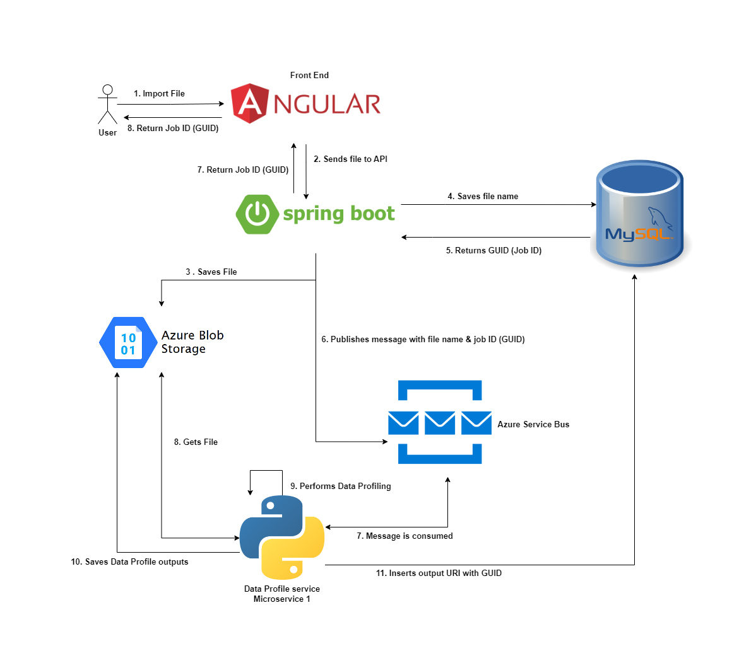

Figure 30. System architecture of data upload feature

#### 4.4.3.2 Data Profile

All the necessary operations for data profiles will be finished when the user uploads the data. So, when users want to see the data profile results, they can give their job ID to the front end. It will be passed to API, and from there, the database will be queried with the job ID and return the URI of the data profile output. Once the API gets the URI, it will fetch a file from the blob storage and return it to the end application, where the data will be transformed into visualization.

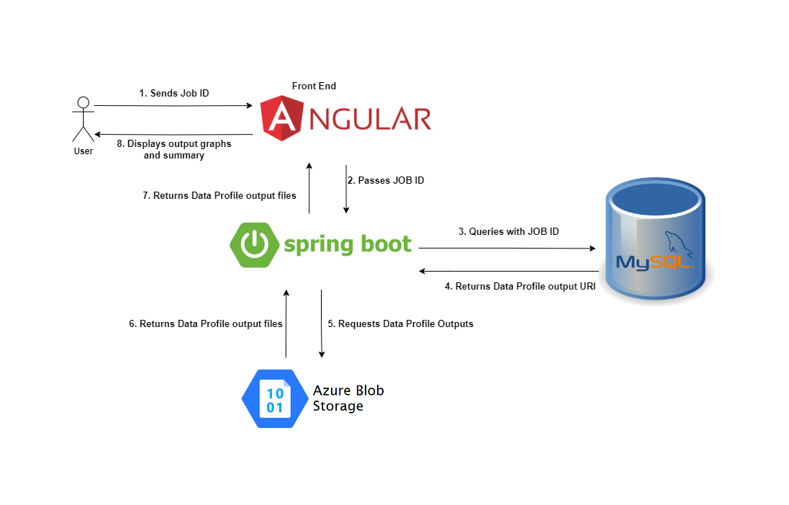

Figure 31. System architecture of data profiling feature

#### 4.4.3.3 Data Cleaning

When the user is satisfied with the data profile, they can start cleaning data. They can set the rules from UI for data cleaning row by row; Angular collects them and sends them to the spring boot API. From there, the rules are stored in the database. This set of rules and job ID is published as a message to the queue. The Python data cleaning service takes the message and starts working on it, gets the file from the blob, cleans it, and saves it back to the blob. Finally, it saves the result data set URI in the database.

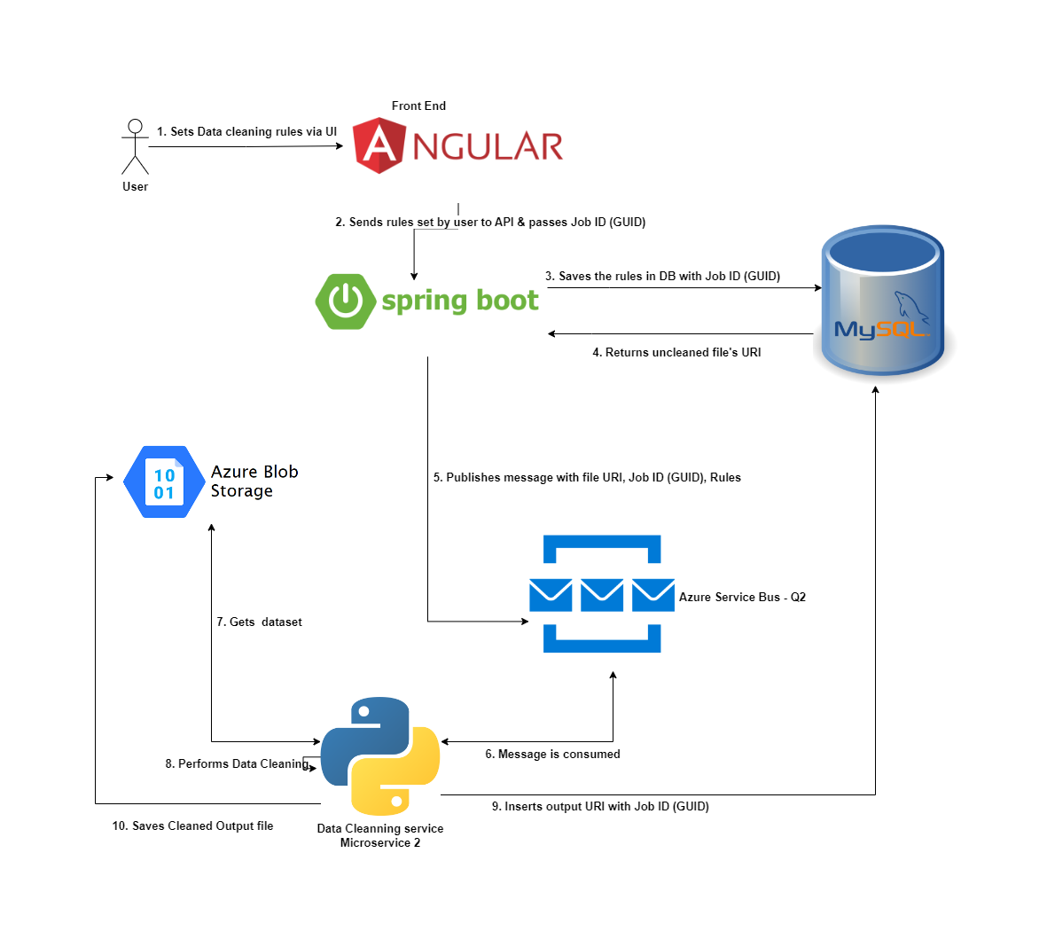

Figure 32. System architecture of data cleaning feature

#### 4.4.3.4 Data Download

When a user requests the clean dataset with their JOB ID, angular makes the HTTP request to spring boot application with job ID. API will get URI from the database, fetch files from blobs and send them to UI where users can download them.

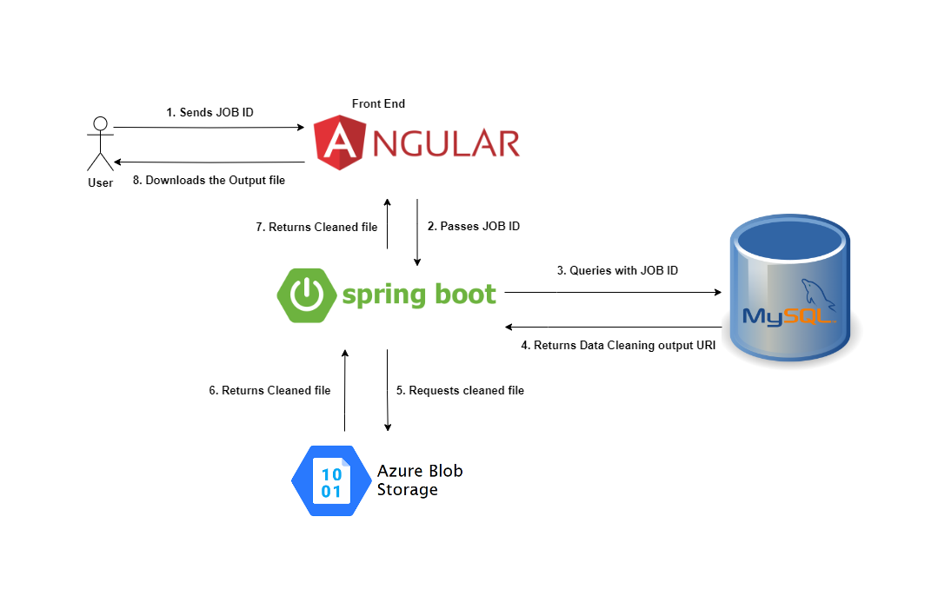

Figure 33. System architecture of data downloading feature

## 4.5 Version Control System

### 4.5.1 Understanding GitHub Flow and Git Flow

We use a version control system to save, keep track of our team's progress and prevent from losing the changes. The version control system we are using for this project is GitHub. We can follow multiple flows to merge our changes into production, but the one we choose is the GIT flow.

We planned to do a release after each sprint, and we needed multiple branches like development and QA to merge changes and test for each sprint, which is not the case with GitHub flow, where we use only two branches to track our changes that is why we choose GIT flow (Hyett, 2022) & (Phillips et al., 2011). We use GIT flow with some tweaks.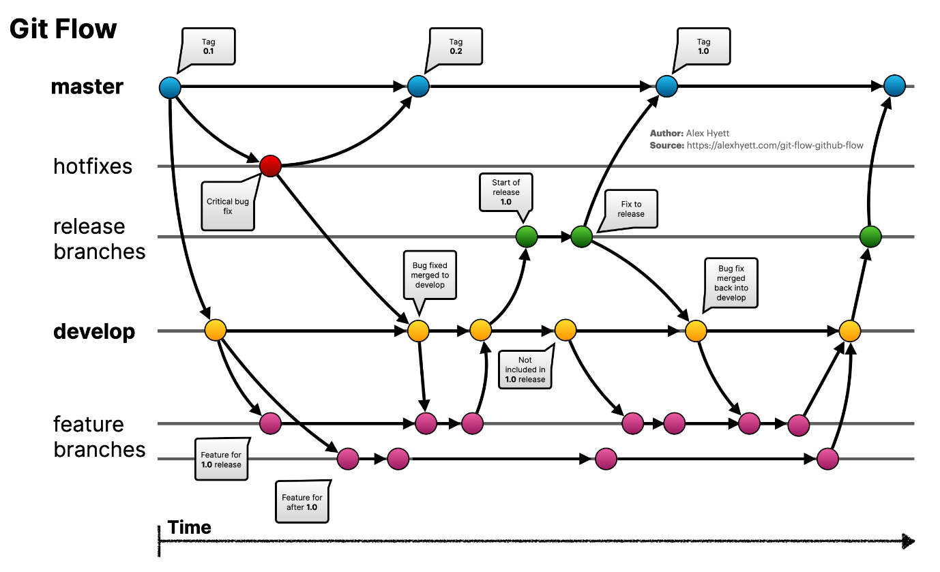

Figure 34. Git Flow (Hyett, 2022)

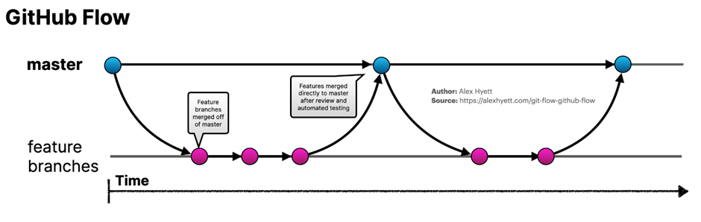

Figure 35. GitHub Flow (Hyett, 2022)

### 4.5.2 Version Control Workflow for Our System

Developers will use Feature Branches to push their code. Every story will have its feature branch. Once the developer is happy with the feature branch, he can request team members to merge into the development branch. Our team has set the criteria to have a minimum of 2 approvals to merge. Once all the stories are closed for that sprint, all the changes will be moved to QA, which will be deployed and tested.

We are using regression testing so far but plan to do automation. If the branch has been signed off to merge, it will be merged into the production branch, where I will be deployed, and quick testing will be done. After the sprint is over with the production code deployed, it will be moved to the main branch for backup just in case anything goes wrong. This process is and will be followed throughout the project.

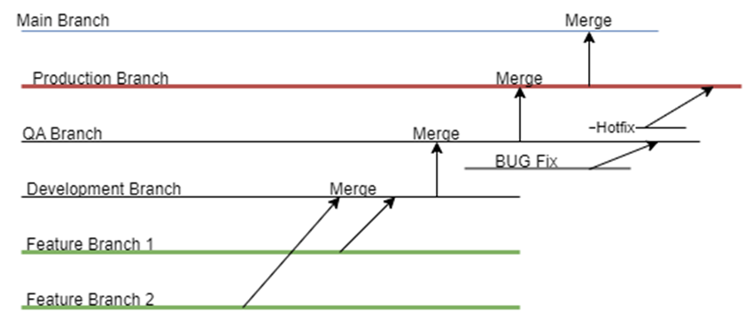

Figure 36. Version control workflow of our application

## 4.6 User Interface Design Strategies

We have incorporated two distinct UI design patterns: Modern UI and Accessible UI. This section offers a comprehensive overview of these design approaches.

### 4.6.1 Modern UI

We have adapted our interface to the Glass morphism design trend to provide a modern and visually engaging user experience. This approach aligns with contemporary design aesthetics and enhances user engagement and immersion, making information more appealing and accessible to our student users.

### 4.6.2 Accessible UI

#### 4.6.2.1 Our Approach

In addition, we have prioritized inclusivity and an improved user experience for students with disabilities. A colour scheme toggle feature is accessed through a user-shaped button, catering to those with visual impairments like colour blindness (7 Ways to Make Your Angular App More Accessible, 2019). Moreover, we plan to incorporate audio descriptions to facilitate navigation further. When users hover their cursor over specific elements, such as buttons or links, they will receive audio feedback providing information about the function or purpose of that object.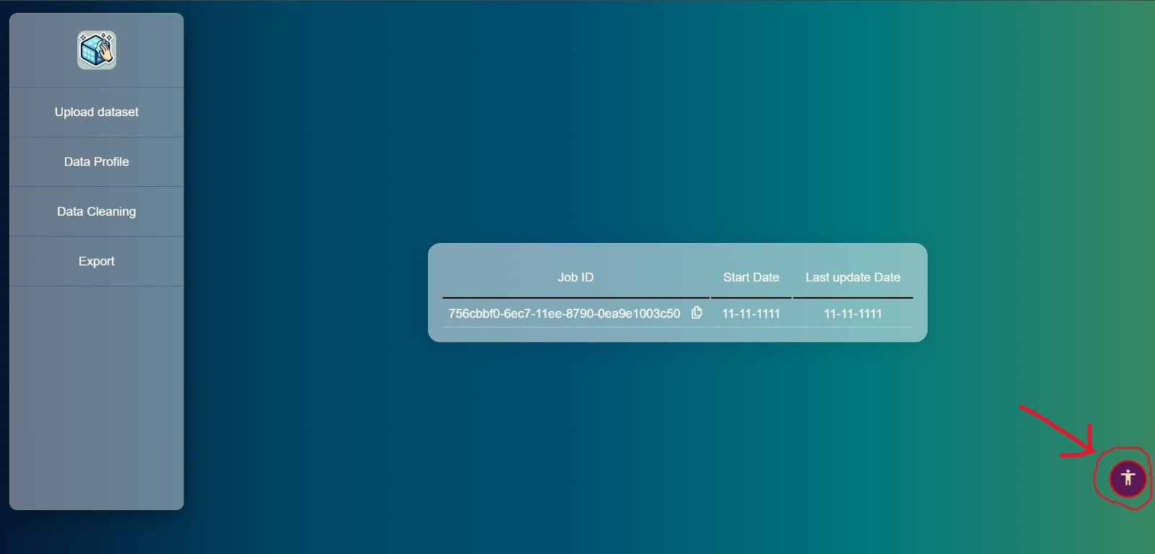

Figure 37. Screenshot of accessibility feature button from 'Data Polish' application

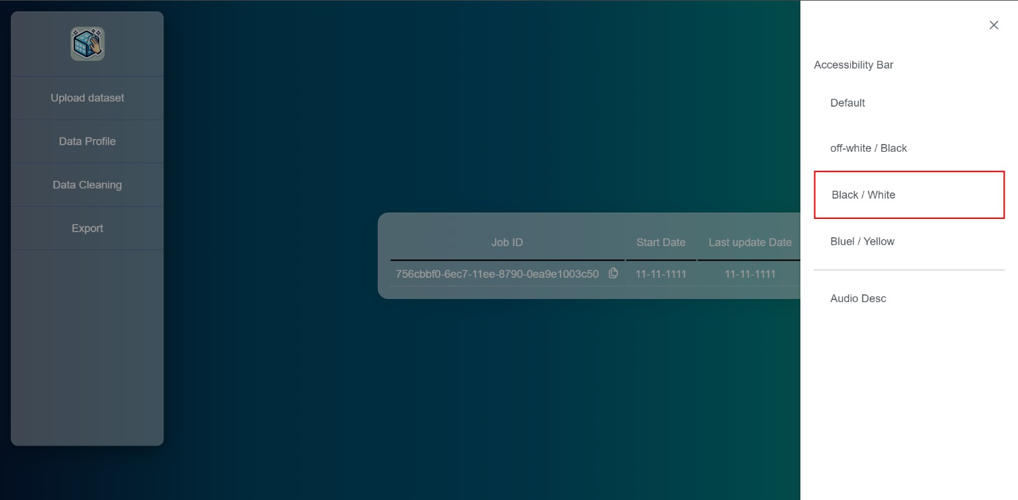

Figure 38. Screenshot of Accessibility Bar from 'Data Polish' application

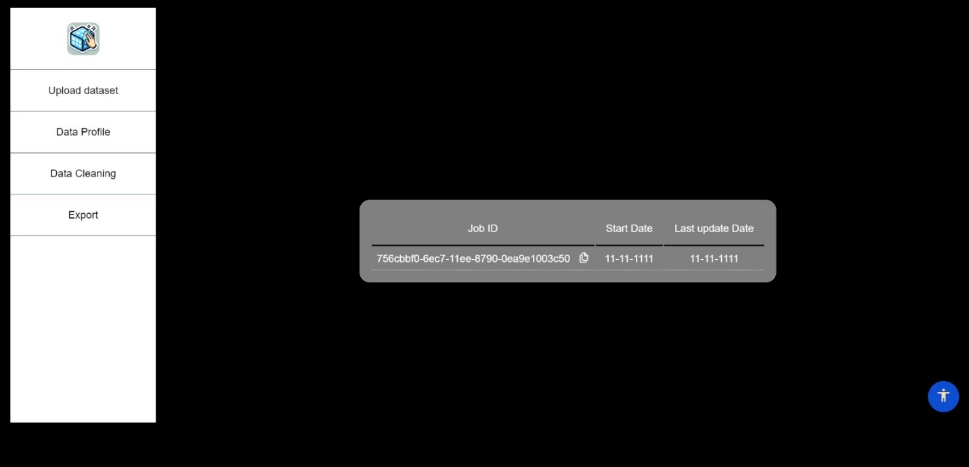

Figure 39. Screenshot of Black/White version of 'Data Polish' application

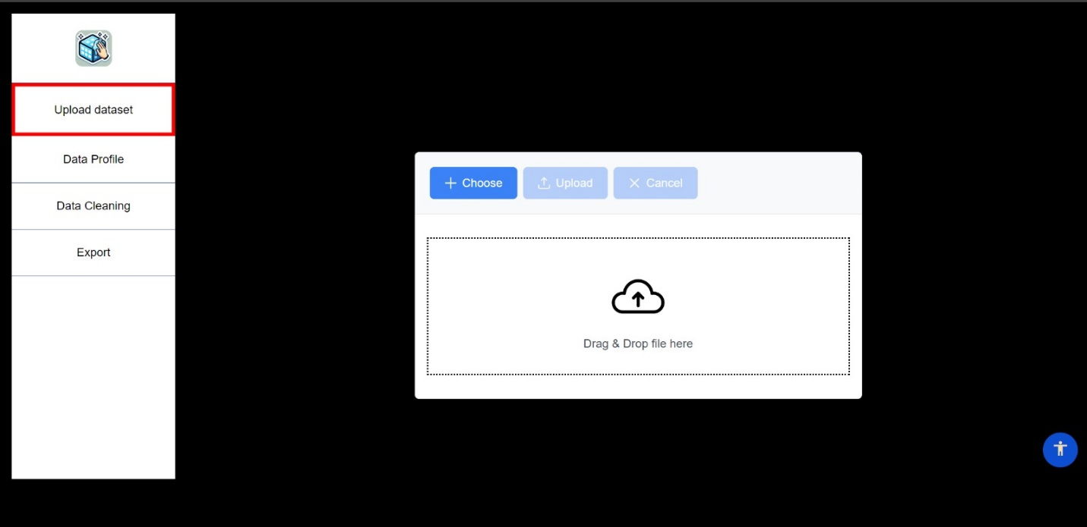

Figure 40. Screenshot of Black/White version of 'Data Polish' application highlighting the side menu on the left

#### 4.6.2.2 Research on Accessible Frontend

In our literature review on font types and sizes for accessibility, it was found that Times and Arial facilitated faster reading. At the same time, Georgia was perceived as the most attractive but less preferred overall (Bernard et al., 2002). Investigating fonts designed for digital content, researchers concluded that Georgia enhances online readability, emphasizing the importance of considering type size and other factors in font design (Boyarski et al., 1998). Exploring electronic display legibility, the study revealed a "letter superiority effect," favouring individual lowercase letters and Verdana and Arial as the most legible fonts (Sheedy et al., 2005). For web reading, 12-point Arial was the most preferred and legible, with the potential for serif fonts like Times New Roman to enhance comprehension at smaller sizes (L. Bernard & Mills, 2000). A study on fonts for dyslexic readers found that sans-serif, monospaced, and Roman fonts improved reading, recommending Helvetica, Courier, Arial, Verdana, and Computer Modern Unicode while discouraging Arial Italic (Rello & Baeza-Yates, 2013).

This paper emphasizes the continued use of Web Content Accessibility Guidelines (WCAG) as a foundational basis for creating accessible web interfaces. It suggests combining user experience studies with these guidelines to ensure comprehensive accessibility (Examining the Perceptions of People with Disabilities on the Use of Accessibility Standards in Web Interface Design, n.d.). This thesis highlights the significance of aural interactive websites, which primarily rely on auditory input instead of visual content. It argues the importance of considering aural interaction in web development and accessibility (Requirements for Aural Web Sites, n.d.). Audio is an accessible medium for individuals who are blind or visually impaired and those with learning challenges or dyslexia. Audio formats offer an alternative for accessing written materials (Accessible Formats, n.d.). This paper offers guidelines for audio descriptions, including considerations like sentence tense, language simplicity, and avoiding slang. It aims to provide a comprehensive training manual for audio description (Snyder, 2020).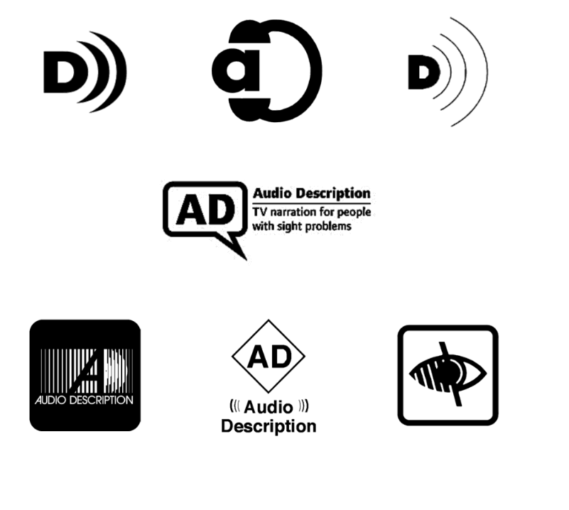

Figure 41. Icons for Audio Description (Snyder, 2020)

The research outlines solutions for making image memes more accessible. It introduces an automated method for converting image memes into alternative meme formats and an authoring interface for users to create accessible memes. The study involved 10 Twitter users with visual impairments who preferred alternative text memes (Gleason et al., 2019). The importance of addressing various accessibility challenges in game development was discussed in this paper, highlighting spatial sound technology's crucial role in enhancing the gaming experience for blind users by providing auditory cues for navigation. It also advocates for customizable font styles and readable fonts like Helvetica, Courier, Arial, Verdana, and Computer Modern Unicode. It also advocates customizable font sizes to improve on-screen readability for low-vision gamers. Additionally, it emphasizes the significance of customizable HUDs in enhancing the gaming experience for individuals with visual impairments. It highlights the potential for smoother game development through these accessible features, even citing community-created mods in games like Skyrim as examples of HUD customization (Khaliq & Torre, 2019).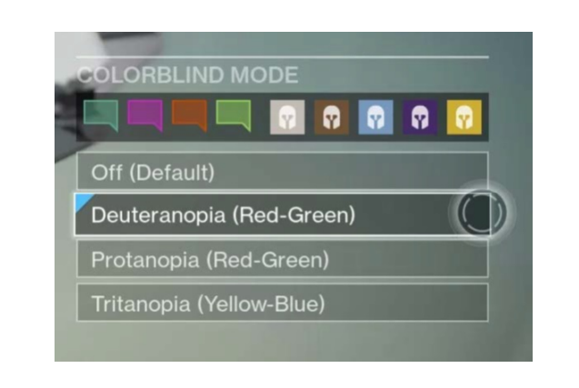

Figure 42. Colour themes bar on web application for user with colour-blindness (Khaliq & Torre, 2019)

We have also researched the Web Content Accessibility Guidelines (WCAG) guidelines to address disabilities like visual impairments for web applications. While WCAG does not specify specific font sizes or styles, it provides recommendations related to text readability and audio descriptions. Here are the relevant WCAG guidelines-

1. **Font Size and Text Readability**:

* WCAG Success Criterion 1.4.4 - Resize Text: Ensure that text can be resized up to 200 per cent without losing content or functionality. Use relative units like percentages or ems for font sizes to allow users to adjust text size using browser features ("Understanding Success Criterion 1.4.4: Resize Text | WAI | W3C").
* WCAG Success Criterion 1.4.5 - Images of Text: If images of text are used, ensure that the text is provided in a way that can be visually customized by the user without loss of content or functionality ("Understanding Success Criterion 1.4.5 | Understanding WCAG 2.0").
* WCAG Success Criterion 1.4.10 - Reflow: Content should be designed so that when the page is zoomed, or text size is increased, users do not have to scroll horizontally to read a line of text. This helps ensure that users can read content without losing context ("Understanding Success Criterion 1.4.10: Reflow").
* WCAG Success Criterion 1.4.11- Non-text Contrast: This guideline ensures that user interface components and graphical objects have sufficient contrast. While it does not specify font size directly, it relates to the readability of text against its background ("Understanding Success Criterion 1.4.11: Non-text Contrast").
* WCAG Success Criterion 1.4.12 - Text Spacing: Ensure that users can adjust text spacing without losing content or functionality. Some visual-impaired users may need to adjust text spacing for readability ("Understanding Success Criterion 1.4.12: Text Spacing").

1. **Font Style**:

WCAG does not have specific guidelines related to font style. However, it emphasizes using clear and legible fonts and sufficient contrast between text and background to ensure readability.

1. **Audio Descriptions**:

WCAG provides guidelines for audio descriptions in video content to make it accessible to individuals with visual impairments.

* WCAG Success Criterion 1.2.3 - Audio Description or Media Alternative (Pre-recorded): For pre-recorded video content, provide an audio description of the visual content to make it accessible to individuals who are blind or have low vision. This involves describing critical visual information that is not otherwise conveyed through the main audio track ("Understanding Success Criterion 1.2.3: Audio Description or Media Alternative (Pre-recorded) | WAI | W3C").
* WCAG Success Criterion 1.2.5 - Audio Description (Pre-recorded): For pre-recorded video content that includes audio descriptions, ensure that the audio description can be turned on or off by the user so they have control over the additional audio information ("Understanding Success Criterion 1.2.5: Audio Description (Pre-recorded) | WAI | W3C").

## 4.7 Frontend Technologies

In building our application's frontend, we have adopted Angular, a powerful JavaScript framework that offers a wide array of advantages for web development.

### 4.7.1 Angular

Angular offers a structured approach to building web applications while ensuring code consistency and maintainability. This section provides insights into the key features and attributes that make Angular our framework of choice (What Is Angular? | Simplilearn, n.d.).4.7.1.1 Modularity and Component-Based Architecture

The modularity and component-based architecture provide a strong foundation for our application development by allowing us to break down the entire system into smaller, self-contained components. This approach enhances code maintainability and reusability, enabling us to build, update, and scale our applications more efficiently. Each component can be developed, tested, and maintained independently, fostering developers' collaboration, and ensuring a well-structured and organized codebase. This modular approach is instrumental in streamlining development workflows and facilitating the creation of complex applications while keeping the codebase manageable and clean.

#### 4.7.1.2 Two-Way Data Binding

Angular's support for two-way data binding is a pivotal feature that simplifies data synchronization between the user interface and the application's logic. This bidirectional connection enables real-time updates, where changes in the user interface instantly reflect in the underlying data and vice versa. This seamless communication enhances the user experience, reduces the complexity of managing data, and ensures consistency throughout the application. Two-way data binding significantly streamlines the development process, making creating responsive and interactive interfaces easier while maintaining the integrity of the underlying data structures.

#### 4.7.1.3 Dependency Injection System

Dependency Injection System simplifies managing and sharing dependencies across various components and services, promoting a modular, maintainable, and testable codebase. This system is pivotal in enhancing code organization and collaboration among developers.

#### 4.7.1.4 Integration of RxJS

Angular seamlessly integrates RxJS, a library for handling asynchronous and event-driven operations. This integration streamlines data stream management, simplifies handling HTTP requests, and enables real-time updates within the application.

#### 4.7.1.5 Unit Testing Support

The robust unit testing support ensures the reliability and quality of our application code. Providing a comprehensive framework for testing components, services, and interactions it allows us to detect and rectify issues early in the development process, resulting in a more stable and error-free application.

## 4.8 Backend Technologies

A tabular format of the Back-end technologies we are using in our application are follows:

|  |  |
| --- | --- |
| Backend API | Java – Spring Boot |
| Relational DB Engine | MySQL |
| Relational DB Hosting | AWS RDS |
| File Storage | Azure storage Account blob storage |
| Messaging system | Azure Service bus queues |
| Data profiling & cleaning | Python microservices |
| API Hosting technology | Tomcat server |
| Python hosting technology | Linux Daemon service |
| Api and python hosting server | AWS EC2 |
| Server operating System | Ubuntu server |

Table 1. Summary of technologies used for Backend Development

### 4.8.1 Backend API – Java Spring boot

The entire application relies on backend APIs. We chose Spring Boot because everyone from our team understands essential java. Spring Boot has a large and active community. This means we can find many resources, tutorials, and libraries to help with project development. Spring Boot provides built-in security features, including support for OAuth, JWT, and other authentication and authorization mechanisms. This makes it easier to secure our API.

Spring Boot makes writing unit tests for our APIs easy and mock certain functions with injecting dependency. Spring Boot is suitable for building microservices. Our application runs almost entirely on microservices, small, independent services that can be deployed and scaled individually. It provides features like embedded containers, which simplify the deployment and scaling of microservices (Kushnir, 2021).

### 4.8.2 Relational Database and MYSQL

We decided to use a relational Database because it enforces a structured schema, which ensures data consistency and integrity. They have a proven track record of stability and reliability. Relational databases are very good at handling complex queries. Initially, we chose Oracle DB, but later, due to the limitation in cloud services available, we switched to MySQL Engine, which also has all the necessary features we needed (What Is a Relational Database?, 2020).

### 4.8.3 AWS RDS

AWS RDS, a fully Managed Service, takes care of many routine database management tasks, such as patching and backups. This lets us focus on the application's data and functionality rather than database administration. AWS has a large and active community and offers robust support options, including documentation and forums (AWS, 2019).

### 4.8.4 File Storage - Azure storage Account blob storage

It is a versatile and scalable solution for storing large amounts of unstructured data. To prevent vendor lock-in, we went for Azure rather than AWS S3 bucket (cloudflare, 2021). A multi-cloud strategy is an approach where an organization uses cloud services and resources from multiple cloud providers simultaneously to prevent vendor lock-in, increase redundancy and reliability, and take advantage of the unique features and pricing structures of different cloud providers.

### 4.8.5 Azure Service Bus

The Azure Service Bus offers a reliable and durable messaging system that ensures messages are delivered despite failures, making it a robust choice for building applications that require guaranteed message delivery. Again, to prevent vendor lock-in, we used Azure over AWS Messaging (cloudflare, 2021).

### 4.8.6 Python microservices - Data profiling & cleaning

We have adopted Python microservices for data profiling and cleaning for several convincing reasons. Python boasts a rich ecosystem of open-source libraries tailored for data manipulation, including renowned tools like Pandas, NumPy, and SciPy. Furthermore, Python's clean and expressive syntax fosters code clarity, enabling us to articulate data-cleaning tasks effectively. We harness libraries such as Matplotlib and Seaborn to enhance the data-cleaning process, empowering us to glean valuable insights through data visualization.

Additionally, Python's versatility allows seamless integration with other data-related tools and platforms. Its compatibility with popular data storage solutions and database systems simplifies data access and retrieval. Moreover, the extensive community support and wealth of online resources make Python a depedable choice for addressing data quality and analysis challenges in our microservices architecture.

### 4.8.7 API Hosting Technology - Tomcat server

While Spring Boot applications can be packaged as standalone JAR files, Tomcat can also deploy traditional WAR (Web Application Archive) files, a standard format for Java web applications. This flexibility allowed us to choose the deployment method that best suited our needs.

Tomcat can be used with a reverse proxy server like Apache HTTP Server or Nginx to handle tasks like load balancing, SSL termination, and serving static content. This setup provides additional capabilities and enhances security.

Spring Boot simplifies the deployment of the application on Tomcat. Spring Boot's embedded Tomcat configuration means we do not need to set up an external Tomcat server; everything is bundled into the Spring Boot application. It is known for its lightweight design and efficiency.

### 4.8.8 Python hosting technology - Linux Daemon service

Hosting Python microservices as Linux daemons or background services offers several advantages, making it a practical choice for running microservices in a production environment. Here are some reasons why we chose to host Python microservices as Linux daemons:

Linux daemons run in the background, independent of user sessions. This allows our microservices to execute continuously and independently of user interactions, making them suitable for long-running and non-interactive tasks. Linux daemons benefit from the stability and robustness of the Linux operating system. They can be configured to restart automatically in case of failures, helping ensure high availability. Running microservices as daemons can be resource-efficient. We can control the resource allocation (CPU, memory) to optimize performance and prevent resource contention with other processes. Daemons can be configured with limited permissions and security restrictions, reducing attacks.

### 4.8.9 AWS EC2

Here, we went for a low-cost virtual machine with high reliability on a pay-as-you-go basis. Since we need complex deployments, we could not deploy our services on serverless architecture.

EC2 provided us with more control over the environment. We have direct access to the underlying operating system, allowing us to configure and optimize it for our needs. Cost-effective for Resource Intensive workloads like out data cleaning, deployments of microservices architectures and Custom Networking

### 4.8.10 UBUNTU server

We chose the Ubuntu server as OS because of its reliability, Long Term Support (LTS), security and ease of use since it is a Debian flavor.

## 4.9 Data

We are taking test datasets from Kaggle and other dataset repository services to test the system. These datasets will typically be over at least 60,000 rows and more than 13 columns but less than 30 columns. Currently, we support only CSV file format for dataset imports. When the uploads a file, this will be stored in the Azure storage account blog storage.

# 5.Evaluation

This section of the report discusses the evaluation metrics which have been used and techniques planned. This process took 5 phases.

## 5.1. Phase 1 Survey

Initially, we aimed to determine the preferred features and identify our primary users. Surveys are a standard tool for this, but they come with challenges. In a study on how to run surveys, Stantcheva (2023) emphasized the importance of avoiding bias, highlighting the need to approach question design carefully (Stantcheva, 2023). Our survey, as evidenced in Figures 6 through 11, might have inadvertently led respondents to focus on their individual preferences. Additionally, sharing the survey on LinkedIn influenced some responses, as connections might have participated out of courtesy rather than genuine interest. Despite these challenges, we still gained insights into our primary user base, which benefitted our project's next phase.

## 5.2. Phase 2 Initial Prototype

In developing our product, crafting a prototype became imperative, not just any prototype, but one that would comprehensively represent our vision. Figures 18 to 22 are not mere illustrations; they present a journey through our product's core functionalities, from the initial step of data importing to the final process of data exporting. Nevertheless, more than visual representation is needed to determine the efficacy or completeness of our prototype. The users, the very individuals for whom this product is intended, hold the insights. Their feedback on visual elements like the logo, design, functions, and what might be absent from our offering will be our next steps toward the interview phase.

## 5.3. Phase 3 Interviews

Our team carried out four pivotal interviews in the project's fourth week. Comprising ten primary questions, each followed by an in-depth query, these conversations were carefully documented and archived on GitHub (GitHub, 2023). Our objective post these dialogues was clear: gauge the calibre of feedback. An intriguing observation by Knott, Rao, Summers, and Teeger (2022) suggests that online interviews often need more depth and context than face-to-face interactions. (Knott, Rao, Summers, and Teeger, 2022) Recognizing this, we embarked on a twofold strategy: firstly, cultivating genuine engagement with our interviewees, and secondly, mitigating the inherent biases of surveys by crafting questions that extended beyond our immediate interests. Drawing inspiration from Fitzpatrick's 'The Mom Test' (2013), our questions pivoted from our product's features to the broader challenges users faced and their coping mechanisms.

Moreover, participants were invited to assess our prototype critically. Their insights were illuminating, advocating for enhancements ranging from logo introduction to comprehensive data profiling, as illustrated in Figure 20, and embracing statistical elements like standard distribution. These invaluable suggestions, available for reference on GitHub (GitHub, 2023) and the table displayed below from Figure 43 until Figure 46, underpin our next developmental phase.

|  |  |
| --- | --- |
| **Interview Number** | 1 |
| **University & degree** | MSc.in Data Science From Technological University Dublin |
| **Knowledge of competitor** | None |
| **Pros** | * Associates the name well with the tool * Loves the interface simplicity in data profiling on page 3 of our prototype * Would use this tool in his current dissertation |
| **Cons** | * The null cleaning is a little too basic as each null case is unique |
| **Comments** | I would love there to be an Automatic way to clean my data so I can export it and get straight into my python project. |
| **Changes to be made** | * Simplify our UI for upcoming generations on all pages 1-5 * Allow for multiple null value operations on page 4 * Allow for a generic automatic cleaning on page 4 |

Table 2 .First interview feedback summary

|  |  |
| --- | --- |
| **Interview Number** | 2 |
| **University & degree** | MSc.in Data Science From Technological University Dublin |
| **Knowledge of competitor** | None |
| **Pros** | * Easily associates name with the application functionality * Loves the feature list |
| **Cons** | * The application is too simplistic and minimalistic * Looks very unprofessional |
| **Comments** | Since I work a lot with excel sheets, I would love the ability to import excel as well as a csv and export also in excel. |
| **Changes to be made** | * Allow users to import and export excel files for page 1 and page 5 * Improve our website professionalism with an updated UI design from page 1 - 5 |

Table 3. Second interview feedback summary

|  |  |
| --- | --- |
| **Interview Number** | 3 |
| **University & degree** | MSc.in Data Science From Technological University Dublin |
| **Knowledge of competitor** | Minimal ( heard of oracle ) |
| **Pros** | * Loves the colourless background * Loves data profiling * Associates the name with the tool easily * Likes the process from being a step by step process with the ability to go back * Really likes the ability to go in depth cleaning on column basis * Likes the no code environment |
| **Cons** | * The lack of statistical understanding is missing from our project |
| **Comments** | Since I spend most of my time cleaning data the ability to see the statistical distribution between all columns would be great, I would love to deal with categorical data, and if you could make it more like “Excel” and less like “Orange” that would be ideal. |
| **Changes to be made** | * Add statistical insight into data profiling on page 3 * Add methods of dealing with categorical features e.g. dummies on page 4 * Make the application more interactive but not confusing , keeping it minimalistic. On page 2 |

Table 4. Second interview feedback summary

|  |  |
| --- | --- |
| **Interview Number** | 4 |
| **University & degree** | MSc.in Data Science From Technological University Dublin |
| **Knowledge of competitor** | None |
| **Pros** | * Really likes the name as its easily associated with the application * Likes the UI of the application |
| **Cons** | * Lack of excel importation * Lack the ability to work with geospatial data |
| **Comments** | I work with excel and other application and the ability to have excel and maybe a tool that would help me clean my geospatial data would greatly help me in my dissertation |
| **Changes to be made** | * Implement “Excel” import and export capabilities on pages 1 and 5 |

Table 5. Fourth interview feedback summary

## 5.4. Phase 4 First Working prototype Evaluation (MVP)

Post MVP, the team will continue to focus on usability evaluation while ensuring good quality software with continued software evaluation. Both evaluation methods post-working prototypes will adhere to a more structured approach.

### 5.4.1 System evaluation

Post MVP, the team will involve a few select target users from the user feedback sessions to be more active participants in the design and development of the product. Participatory design has proven to be a successful evaluation method as it encourages genuine participation from the users, which ensures valuable feedback, and the resulting end product can meet the most urgent requirements of the user (Kautz, 2011). Since the start of this project, it has been an objective of the team that the system's functionality is user-driven, and employing participatory design will contribute to satisfying that objective.

### 5.4.2 UX evaluation

The team will employ the Think-Aloud protocol for evaluating the UX. The Think-Aloud protocol is a technique where a user vocalises their thoughts while interacting with the product when given a set of tasks. This technique will give us direct information on the users' thinking and cognitive process while using the product. It will allow us to identify the usability flaws of the UX and give us insights for improvements (Doi, 2021).

In Doi's paper he outlines a SCAT (Step Coding Analysis Technique) for analysing the qualitative data captured from the Think-Aloud protocol:

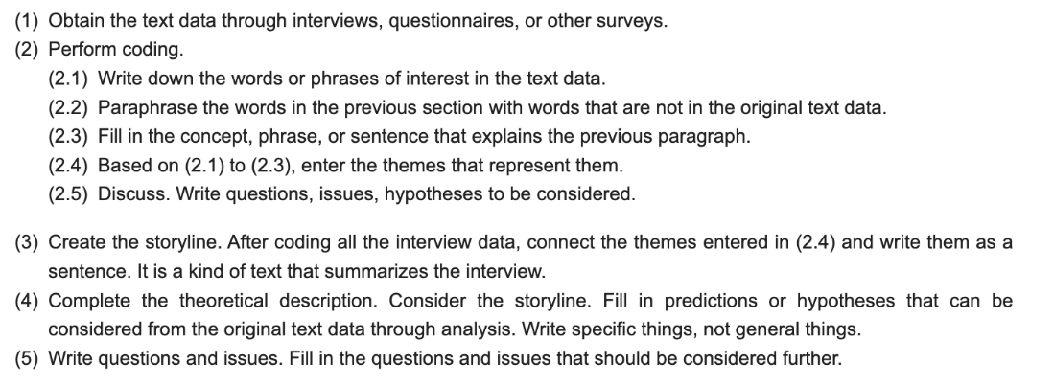

Figure 43. SCAT technique for analysing qualitative data from the think aloud protocol (Doi, 2021)

### 5.4.3 Software Evaluation

Software evaluation is critical for the product's success as it ensures good quality code, which leads to enhanced performance, fewer bugs, easier maintenance, and a more reliable experience for the end user (Honest, 2019). For each subsequent application release, the team will continue performing unit and integration testing to ensure every component works fine individually and as a whole.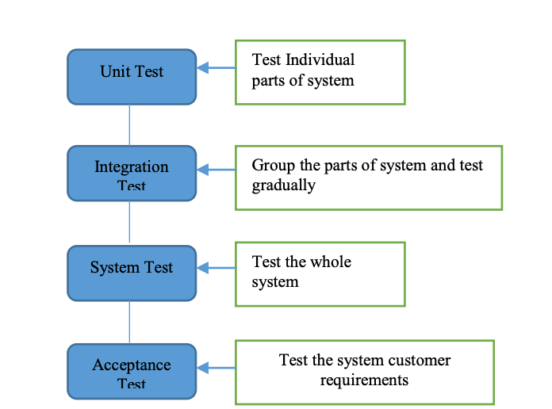

Figure 44. Levels of testing (Honest, 2019)

#### 5.4.3.1 Evaluation of python microservice (data cleaning and profiling)

Currently, the team have implemented unit tests to assess each function of the Python code, ensuring that each component performs its intended functions accurately and effectively and that the data cleaning and profiling outputs are correct. For subsequent releases, the team will continue to employ more rigorous unit tests, which will test the functionality of the Python code against edge cases.

#### 5.4.3.2 Evaluation of Backend

The team will utilize Postman to perform end-to-end testing for each backend API and will continue to do so as primary testing. Also, we will write unit test code to assess individual components, functions, and methods within the API using tools like JUnit. For integration testing, we will evaluate how different parts of the API interact with one another. This will ensure that various components work harmoniously when combined. Spring's testing framework provides support for integration testing. We will do load testing to assess how the API performs under high loads and concurrent user requests. Tools like Apache JMeter or Gatling will simulate heavy traffic and measure the API's responsiveness and stability

#### 5.4.3.3 Evaluation of Frontend

We will perform unit testing for Angular applications with tools like Jasmine for writing test specifications and Karma for test execution. Unit testing will validate the behaviour of individual components, services, and modules. Angular also provides its testing framework for integration testing, which will help us test the interaction between different application parts, ensuring they work together harmoniously. Additionally, we will explore automation testing with tools like UiPath to streamline repetitive and rule-based testing processes, enhancing testing efficiency and precision.

## 5.5. Phase 5 Final Evaluations

In the final phase of the product, there will be no new features, only slight improvements to UI, performance, and stability (New feature code freeze on December 1st and general release on December 14th). The evaluation for this phase will focus on UX, software and performance. The team will employ the techniques mentioned in section 5.4 for software and UX evaluation. In contrast, for performance evaluation, the team will look to utilize stress testing, where we push the product to its operational boundaries. The team for the final phase will also monitor how long it takes the users to perform tasks when using the product using established tools such as Google PageSpeed Insights and WebPageTest.

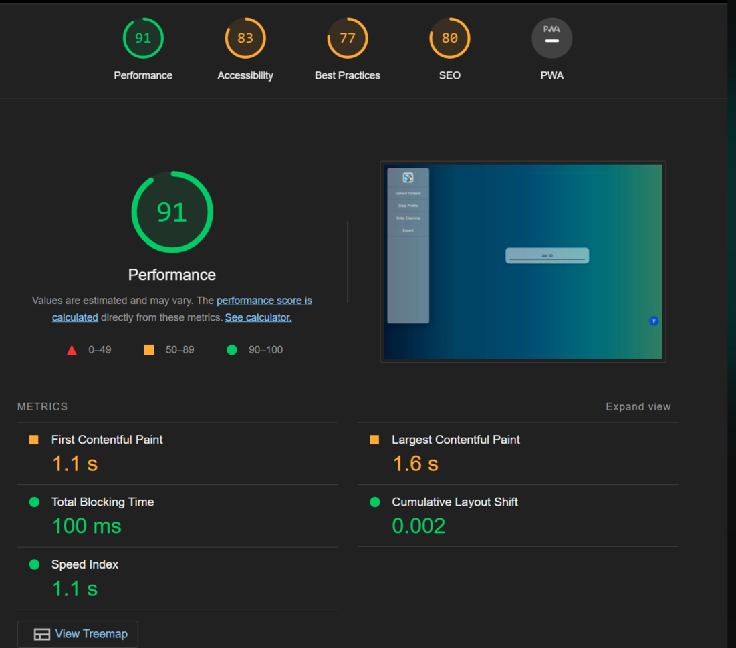

Figure 45. Evaluation metrics from page speed insight

## 5.6. Evaluating accessibility

Accessibility in our product is focused on those with visual impairment issues.

Evaluating accessibility will work with the UX evaluation outlined in the previous phases but requires its own methods. To assess the overall quality of accessibility in our product, we will use accessibility tools such as WAVE. WAVE is a suite of evaluation tools that help developers make their content more accessible to users with disabilities. Other tools, such as SiteImprove, have proved to perform better in some aspects. However, the team's familiarity with WAVE made it chosen as the primary accessibility tool evaluator (Alsaeedi, 2021). 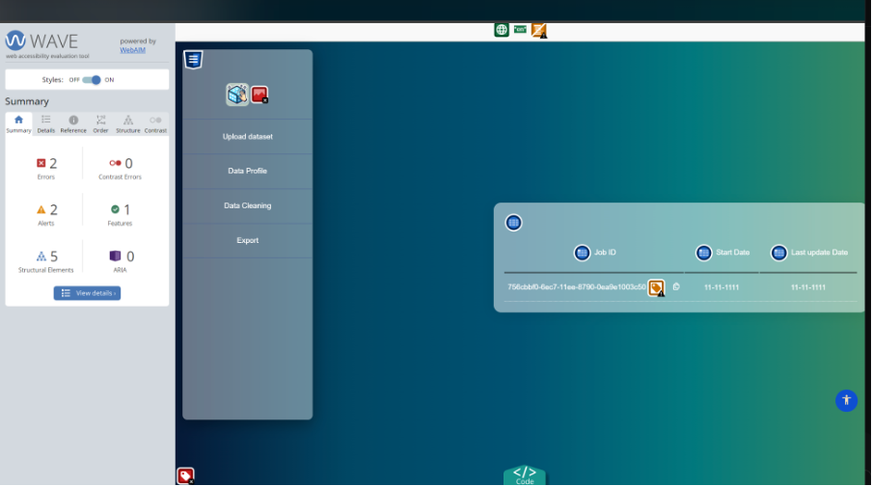

Figure 46. Wave tool assessing Data Polish's accessibility

In parallel to using accessibility evaluation tools, we have identified a user from the user feedback group who has a visual impairment and will continue to get their feedback on the accessibility of the tool. Additionally, we will be looking for more visual-impaired users to test our system.

\

# 6. Conclusion

## 6.1 Project management methodology

Our team employs an agile scrum methodology to manage the project (Hu, Yuan, & Zhang, 2009). Agile with scrum was chosen as it offers flexibility and adaptability and is a more collaborative approach when compared to traditional methodologies such as waterfall. Waterfall has documented limitations, including poor visibility, which can cause a lack of communication between stakeholders and could be better at handling unstructured code (Gabaorv et al., 2021).

The team comprises two advanced software development (ASD) MSc students and three data science (DS) MSc students. ASD members work on the backend and front end of the product, while DS members work on data cleaning functionality and the data profiling dashboard. Below is a breakdown of the team roles

|  |  |  |  |  |
| --- | --- | --- | --- | --- |
| Name | Student Number | Development role | PM Roles | Testing roles |
| Sean McCrossan | [D22124413](mailto:d22124413@mytudublin.ie) | Floater between data cleaning and profiling | Developer | Tester |
| Naveen Maheswaran | D22124491 | Frontend developer | Developer | Tester |
| Oluwatobi Omole | D22125039 | Data cleaning python developer | Developer | Tester |
| Nikodem Adamski | C18415776 | Data profiling python and JavaScript developer | Scrum master/Project manager | Evaluator |
| Umama Sumlin Tasnuva | D22124465 | Backend developer | Developer | Evaluator |
|  |  |  | *Roles rotate every sprint | |

Table 6. SCRUM roles per member

A sprint cycle lasts one week, and a daily scrum (15-30 minute) meeting is conducted to report on progress and challenges from each team member. Jira, GitHub and Slack are used to manage the project along with requirement spreadsheets. GitHub is the project repository used to track pull requests and commits. Jira is used to create epics, stories and issues, which are the tasks assigned at the sprint kick-off meeting every Monday, and progress is tracked throughout the week in the daily scrum. Slack is the team's internal messaging tool. GitHub, Jira and Slack are all linked to each other.

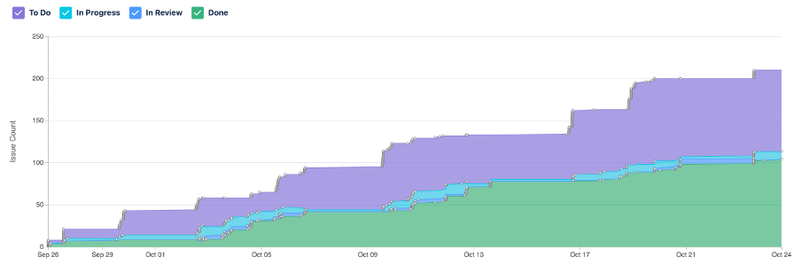

Figure 47. Jira issue cumulative report

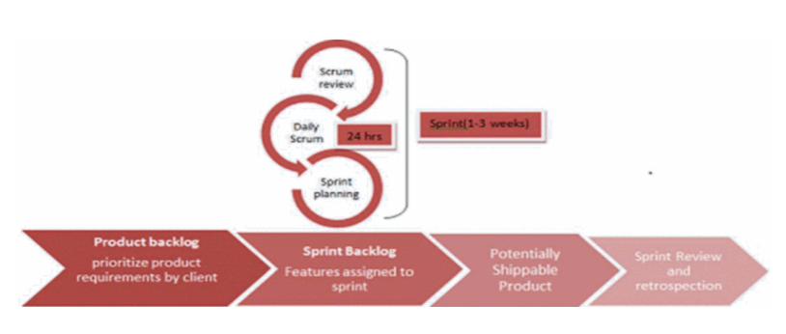

Figure 48. Sprint cycle (Srivastava, Bhardwaj and Saraswat, 2017)

The development of the project is scheduled to stop on the 1st of December to allow sufficient time for testing, evaluation and improvements before the final release.

|  |  |  |  |
| --- | --- | --- | --- |
| Week No | Week | Features to be included | Comments |
| 2 | 25th - 29th Sep | Data Import | Start of work and research |
| 3 | 2nd - 6th Oct | Data Quality checks and export of data | Data quality check module created, not all functions made it to final |
| 4 | 9th-13th Oct | Data cleaning | Data cleaning module created, only dataset wide cleaning up taken |
| 5 | 16th - 20th Oct | Data Profiling images | D3 dashboard scrapped for this release, only static pyplots |
| 6 | 23rd - 27th Oct | UI improvements and stability | Worked on stability |
| 7 | 30th - 3rd Nov | Data Preview and Data Import V2 | Data preview to be finished |
| 8 | 6th - 10th Nov | Data profile dashboard and data cleaning column level | D3 dashboard and column level cleaning |
| 9 | 13th - 17th Nov | Create new columns, Dimension reduction | Not finalised but more complex features to be released |
| 10 | 20th - 24th Nov | Statistical analysis data profile visuals and annotation | More complex charts in data profiling |
| 11 | 27th - 1st Dec | Multiple file imports | Allow users to upload multiple files |
| 12 | 4th - 8th Dec | Testing and evaluation | Small improvements or possible new functionality (code freeze) |
| 13 | 11th - 15th Dec | Testing and evaluation | Stop all functionality (code freeze) |
| 14 | 18th - 22nd Dec | Final report writing and presentation | Product stable and general release. |

Table 7. Feature schedule timeline

## 6.2 Team meetings

The meeting schedule follows the agile scrum methodology (Srivastava, Bhardwaj and Saraswat, 2017). Daily scrum meetings are 30 minutes and occur online every Tuesday, Wednesday, and Thursday. Each team member answers the following questions:

1. What did you do yesterday?
2. What are you planning to do today?
3. Are there any blockers impacting your progress?

In these meetings, team members are encouraged to share ideas or research they have completed, giving the team visibility and raising other issues in front of the team. The team has a sprint planning meeting every Monday to assign tasks to team members to complete during the sprint. On Friday, the team has two in-person meetings after the lectures. At the sprint review meetings, we discuss how the current sprint went and the goal of the following sprint, and then we organize the project backlog of Jira. In the retrospective, we anonymously list, to ensure an open dialogue, what went well, what did not go well and what we should start doing; the team then discusses each of these points.

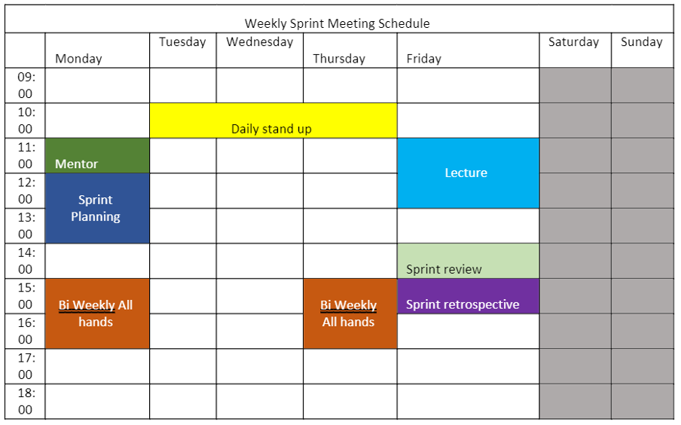

Figure 49. Team meeting schedule (Bi Weekly all hands has been removed)

More specific meetings are scheduled on an ad-hoc basis through huddles on Slack between relevant team members. Every few weeks, the team will organize a design workshop where we will meet on campus to design and prioritize features for the product based on the information gathered from research, competitor analysis and user feedback.

Big decisions are made by consensus within the team unless there are instances where expert decision-making is required. The role of scrum master/project manager is rotated weekly.

## 6.3 Challenges

### 6.3.1 Integration of parts into MVP

To mitigate issues of deployment of the final product, as reported by previous year's teams, the team's early objective was to deploy a minimal viable product (MVP) by week 4. While they could show each of the product's components by week four and have some integration, the team could have delivered a fully stable MVP, which delayed planned user feedback sessions.

This project has been a steep learning curve in the overall tech stack, and the team had to pivot early to try and achieve the MVP milestone. For example, the team could not include the column-specific cleaning functions created by the DS team or the D3 dashboard in this release due to the integration issues and capacity of team members.

There have been numerous changes since the first plan, including switching from a Python Flask API to a microservice for the backend. Members of the data science team building the Python functionality had to watch tutorials on YouTube on how to build a Flask API. Before this project, the DS team were familiar with only Python scripts in Jupiter notebooks.

Capacity is one of the biggest obstacles in getting a fully integrated MVP with some basic functionality. The team has only two ASD members compared to other teams with three or four, and most of the integration work required is from the ASD team members.

### 6.3.2 Large datasets

During a design workshop, the team discussed edge cases and potential solutions regarding user input; however, each edge case presents a significant challenge, and we will not be able to determine how common they are until more user feedback is acquired. For example, will the product be efficient enough if the dataset contains over 500,000 records? If the dataset has over 30 columns, will the profiling visuals become overcrowded and unusable? We must consider plenty of other edge cases and present a challenge.

### 6.3.3 How to incorporate more complex data science techniques

Data cleaning itself is part of data science, and while it is probably the most time-consuming, most are also essential and not complex. The team has been balancing keeping the product simple for the user and including more advanced data science techniques to make this a worthy project for a data science masters. Machine or deep learning algorithms do not fit into the scope of data cleaning. However, advanced data science techniques such as PCA for dimension reduction and the team need to try and incorporate these techniques into the product, which are also valuable for the user.

## 6.4 Timeline

After 6 weeks (about 1 and a half months) of working together we have a better idea of estimating time for tasks.

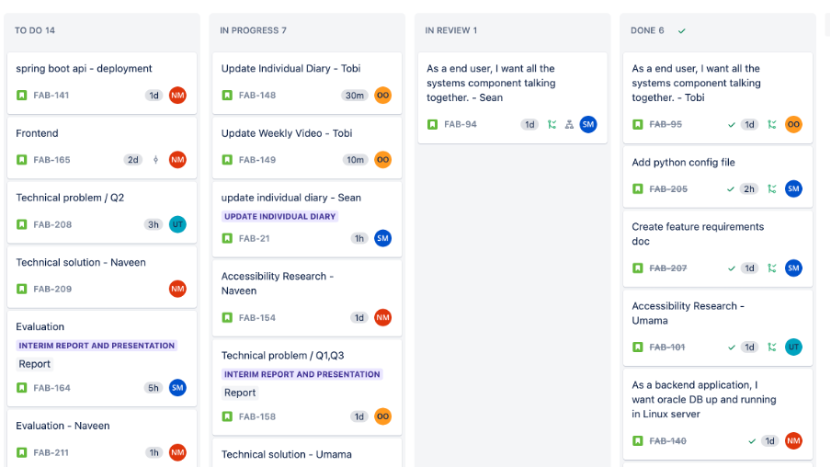

Figure 50. Screenshot of Jira board

The Gantt chart below shows the timeline for the project organized by tasks required for MVP, Beta, Alpha, and general release. The team will focus on the two significant features needed for the next two weeks: basic column cleaning and an interactive data profiling dashboard. Once these have been completed, the team will focus on building more advanced data science functionality such as dimension reduction, creating new columns and statistical profiling of the user data. New features may be included or removed as the project continues, pending user feedback from the MVP and Beta release. The last weeks will be focused on a stable general release and collecting user feedback. A code freeze on new functionality will be in place from December 1, focusing instead on stability and testing.

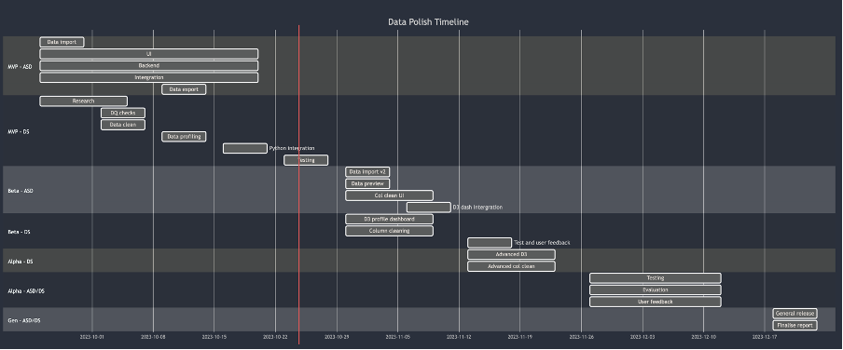

Figure 51. Gantt chart for project completion

# References

Accessible formats. (n.d.). Sight Scotland. <https://sightscotland.org.uk/articles/information-and-advice/accessible-formats>

Alsaeedi, A. (2020). Comparing web accessibility evaluation tools and evaluating the accessibility of webpages: Proposed frameworks. Information, 11(1), 40.

<https://doi.org/10.3390/info11010040>.

Angular base href not showing up in URL. (n.d.). Stack Overflow. Retrieved October 20, 2023, from <https://stackoverflow.com/a/60021179>

AWS. (2019). Amazon Relational Database Service (RDS) – AWS. Amazon Web Services, Inc. https://aws.amazon.com/rds/

Boyarski, D., Neuwirth, C., Forlizzi, J., & Regli, S. H. (1998). A study of fonts designed for screen display. Proceedings of the SIGCHI Conference on Human Factors in Computing Systems - CHI ’98. <https://doi.org/10.1145/274644.274658>

Bureau of Labor Statistics. (2023). EMPLOYMENT PROJECTIONS — 2022−2032. U.S. Department of Labor. <https://www.bls.gov/news.release/pdf/ecopro.pdf>

Chu, X., Ilyas, I. F., Krishnan, S., & Wang, J. (2016, June). Data cleaning: Overview and emerging challenges. In *Proceedings of the 2016 international conference on management of data* (pp. 2201-2206).

cloudflare. (2021). What Is Vendor Lock-In? | Vendor Lock-In and Cloud Computing | Cloudflare. Cloudflare. <https://www.cloudflare.com/learning/cloud/what-is-vendor-lock-in/>

Cupoli, P., Earley, S., & Henderson, D. (2014). Dama-dmbok2 framework. Dama International.

Doi, T. (2021). Usability textual data analysis: A formulaic coding think-aloud protocol method for usability evaluation. Appl. Sci., 11(15), 7047. <https://doi.org/10.3390/app11157047>

Education Indicators for Ireland. (February 2023). Department of Education and the Department of Further and Higher Education, Research, Innovation and Science.<https://www.gov.ie/en/publication/055810-education-statistics/>

Elmuti, D., & Kathawala, Y. (2001). An overview of strategic alliances. *Management decision*, *39*(3), 205-218.

Epoch Converter. (2010). Epochconverter.com. <https://www.epochconverter.com/>

Examining the Perceptions of People with Disabilities on the Use of Accessibility Standards in Web Interface Design. (n.d.). Ieeexplore.ieee.org. Retrieved October 21, 2023, from https://ieeexplore.ieee.org/abstract/document/9274056

Gaborova, M., Karuović, D., Kavalić, M., Radosav, D., Milosavljevć, D., Stanisaljev, S., & Bushati, J. (2021). Comparative analysis of agile and traditional methodologies in IT project management. *Journal of Applied Technical and Educational Sciences (jATES)*, 11(4), 1-24. <https://doi.org/10.24368/jates.v11i4.279>

Gleason, C., Pavel, A., Liu, X., Carrington, P., Chilton, L. B., & Bigham, J. P. (2019). Making Memes Accessible. The 21st International ACM SIGACCESS Conference on Computers and Accessibility. <https://doi.org/10.1145/3308561.3353792>

Gudelli, A. (2023, February 8). WARNING in budgets, maximum exceeded for initial Angular error fix. Angular Wiki. <https://www.angularjswiki.com/angular/warning-in-budgets-maximum-exceeded-for-initial-angular-error/>

Hu, Z., Yuan, Q., & Zhang, X. (2009). Research on Agile Project Management with Scrum method. 2009 IITA International Conference on Services Science, Management and Engineering.

Hyett, A. (2022, November 10). Git Flow vs GitHub Flow. Alex Hyett. https://www.alexhyett.com/git-flow-github-flow/

Bernard, M., Lida, B., Riley, S., Hackler, T., & Janzen, K. (2002). A Comparison of Popular Online Fonts: Which Size and Type is Best? Issue 1 | Past Issues | A-Z List, 4. <https://citeseerx.ist.psu.edu/document?repid=rep1&type=pdf&doi=21a32bc134881ef07726c0e45e3d01923418f14a>

Images not loading from assets folder in Angular. (n.d.). Material Design for Bootstrap. Retrieved October 20, 2023, from <https://mdbootstrap.com/support/angular/images-not-loading-from-assets-folder-in-angular/#:~:text=Dear%20%40mani12->

Jain, N. (2021). Survey versus interviews: Comparing data collection tools for exploratory research. *The Qualitative Report*, *26*(2), 541-554.

Kautz, K. (2011). Investigating the design process: Participatory design in agile software development. Information Technology & People, 24(3), 217-235. <https://doi.org/10.1108/09593841111158356>

Khaliq, I., & Torre, I. D. (2019). A Study on Accessibility in Games for the Visually Impaired. Proceedings of the 5th EAI International Conference on Smart Objects and Technologies for Social Good. <https://doi.org/10.1145/3342428.3342682>

Kushnir, Anastasia. “Pros and Cons of Using Spring Boot.” Insights, 4 July 2021, bambooagile.eu/insights/pros-and-cons-of-using-spring-boot/.

L. Bernard, M., & Mills, M. (2000, July). So, What Size and Type of Font Should I Use on My Website?. <https://www.researchgate.net/publication/265740857_So_What_Size_and_Type_of_Font_Should_I_Use_on_My_Website>

Haas, D., Krishnan, S., Wang, J., Franklin, M. J., & Wu, E. (2015). Wisteria: Nurturing scalable data cleaning infrastructure. Proceedings of the VLDB Endowment, 8(12), 2004-2007.

Honest, N. (2019). Role of testing in software development life cycle. International Journal of Computer Sciences and Engineering, 7, 886-889.

<https://doi.org/10.26438/ijcse/v7i5.886889>.

Phillips, S., Sillito, J., & Walker, R. (2011). Branching and merging. Proceedings of the 4th International Workshop on Cooperative and Human Aspects of Software Engineering. https://doi.org/10.1145/1984642.1984645

Rahm, E., & Do, H. H. (2000). Data cleaning: Problems and current approaches. *IEEE Data Eng. Bull.*, *23*(4), 3-13.

Rello, L., & Baeza-Yates, R. (2013). Good fonts for dyslexia. Proceedings of the 15th International ACM SIGACCESS Conference on Computers and Accessibility - ASSETS ’13, 14. <https://doi.org/10.1145/2513383.2513447>

Sheedy, J. E., Subbaram, M. V., Zimmerman, A. B., & Hayes, J. R. (2005). Text Legibility and the Letter Superiority Effect. Human Factors: The Journal of the Human Factors and Ergonomics Society, 47(4), 797–815. https://doi.org/10.1518/001872005775570998

Srivastava, S. Bhardwaj and S. Saraswat, "SCRUM model for agile methodology," 2017 International Conference on Computing, Communication and Automation (ICCCA), Greater Noida, India, 2017, pp. 864-869, doi: 10.1109/CCAA.2017.8229928.

Snyder, J. (2020). The Visual Made Verbal: A Comprehensive Training Manual and Guide to the History and Applications of Audio Description. In Google Books. Æ Academic Publishing. <https://books.google.ie/books?id=WHorEAAAQBAJ&lpg=PR9&ots=kI221IhXXU&dq=accessibility%20website%20audio&lr&pg=PR17#v=onepage&q=accessibility%20website%20audio&f=false>

Stantcheva, S. (2023). How to run surveys: A guide to creating your own identifying variation and revealing the invisible. *Annual Review of Economics*, *15*, 205-234.

[ubuntu] Error while using apt-get install [Archive] - Ubuntu Forums. (n.d.). Ubuntuforums.org. Retrieved October 20, 2023, from <https://ubuntuforums.org/archive/index.php/t-2151671.html>

“Understanding Success Criterion 1.2.3: Audio Description or Media Alternative (Prerecorded) | WAI | W3C.” Www.w3.org, [www.w3.org/WAI/WCAG21/Understanding/audio-description-or-media-alternative-prerecorded.html. Accessed 24 Oct. 2023](http://www.w3.org/WAI/WCAG21/Understanding/audio-description-or-media-alternative-prerecorded.html.%20Accessed%2024%20Oct.%202023).

“Understanding Success Criterion 1.2.5: Audio Description (Prerecorded) | WAI | W3C.” Www.w3.org, www.w3.org/WAI/WCAG21/Understanding/audio-description-prerecorded.html. Accessed 24 Oct. 2023.

“Understanding Success Criterion 1.4.4: Resize Text | WAI | W3C.” Www.w3.org, [www.w3.org/WAI/WCAG21/Understanding/resize-text.html](http://www.w3.org/WAI/WCAG21/Understanding/resize-text.html).

“Understanding Success Criterion 1.4.5 | Understanding WCAG 2.0.” Www.w3.org, www.w3.org/TR/UNDERSTANDING-WCAG20/visual-audio-contrast-text-presentation.html. Accessed 24 Oct. 2023.

“Understanding Success Criterion 1.4.10: Reflow.” Www.w3.org, [www.w3.org/WAI/WCAG21/Understanding/reflow.html](http://www.w3.org/WAI/WCAG21/Understanding/reflow.html).

“Understanding Success Criterion 1.4.11: Non-Text Contrast.” W3.org, 2019, [www.w3.org/WAI/WCAG21/Understanding/non-text-contrast.html](http://www.w3.org/WAI/WCAG21/Understanding/non-text-contrast.html).

“Understanding Success Criterion 1.4.12: Text Spacing.” Www.w3.org, [www.w3.org/WAI/WCAG21/Understanding/text-spacing.html](http://www.w3.org/WAI/WCAG21/Understanding/text-spacing.html).

What is Angular? | Simplilearn. (n.d.). Simplilearn.com. Retrieved October 24, 2023, from <https://www.simplilearn.com/tutorials/angular-tutorial/what-is-angular#:~:text=Angular%20enables%20users%20to%20build>

Murphy, A. (2023). The Effects of Disinformation Upon National Attitudes Towards the EU and its Institutions. Technological University Dublin. http://www.damiantgordon.com/Research/Dissertations/AlexMurphy.pdf

What is a relational database? (2020). Oracle.com. https://www.oracle.com/ie/database/what-is-a-relational-database/

7 Ways to Make Your Angular App More Accessible. (2019, August 20). Telerik Blogs. <https://www.telerik.com/blogs/7-ways-to-make-your-angular-app-more-accessible>

# Appendix

[TUD-Group-Project/interviews at main · SeanMcCrossanTUD/TUD-Group-Project (github.com)](https://github.com/SeanMcCrossanTUD/TUD-Group-Project/tree/main/interviews)

<https://www.oracle.com/ie/business-analytics/#:~:text=Offering%20valuable%2C%20actionable%20insights%20from,Explore%20Analytics%20products>

<https://openrefine.org/>

Demo link: <https://youtu.be/YrE9eb8-xTw>